# CRDR – Principal Investigator User Manual

Contents

CRDR – Principal Investigator User Manual 1

1.0 Purpose 3

2.0 Scope 3

3.0 Principal Investigator(PI) Features 3

3.1 Manage Studies 3

3.1.1New/Ongoing Studies 3

3.1.2 Repository Studies 3

3.1.3Create Project 3

3.1.4Create Study 3

3.1.5Configure Study 3

3.1.6Copy eCRf from Global Library 3

3.1.7Create New eCRF 3

3.1.8Left Navigation menus 3

3.1.9Create Panel 3

Add Panel Button 3

3.1.10Right Navigation Menus 3

3.1.11Publish to Staging 3

3.1.12Publish to Production 3

3.1.13 Backup 3

3.1.14Repository Studies_ Access Study 3

3.2 Admin Tasks 3

Request for Role 3

Request for User 3

Roles X Features 3

Roles X Actions 3

User Management Permissions 3

Email SMPT Configuration 3

SMS SMPT Configuration 3

Change password 3

Using CRDR 3

News & Updates 3

Upload Home page Images 3

Medical Dictionaries 3

Multi Lingual Configuration 3

3.3 News &Updates 3

3.4 CRDR Projects List 3

3.5 Approvals 6

3.6 Secondary Data 6

## 1.0 Purpose

The User manual provides an overview on permissions allotted to Principal Investigator. This manual provides guidelines to Principal Investigator role user to use the PHFI Clinion EDC system.

## 2.0 Scope

The Scope of this manual is limited to describing the system functionalities with respect to Principal Investigator role.

## 3.0 Principal Investigator(PI) Features

PI user logins through login page. On logging in system displays “Manage Studies” page as loading page. Various modules are available to manage multiple activities. On clicking on each module, system navigates user to respective pages and field options.

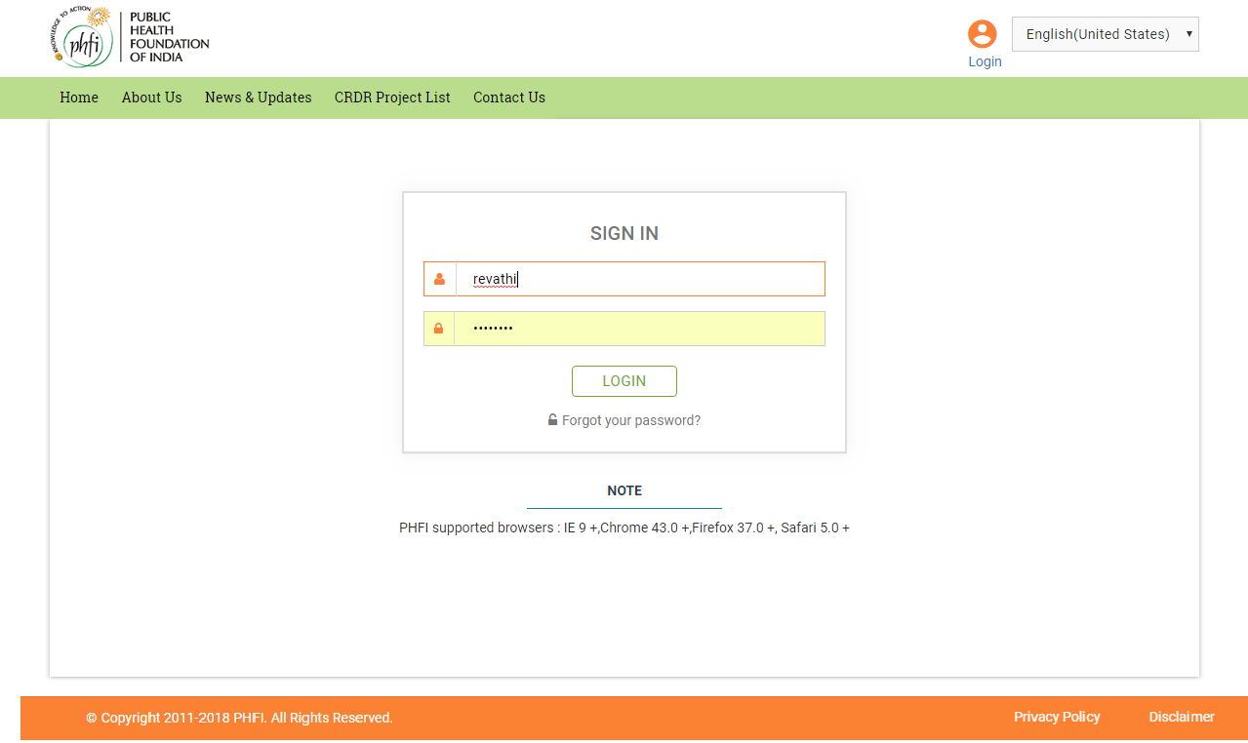

**Figure 01: Login Page**

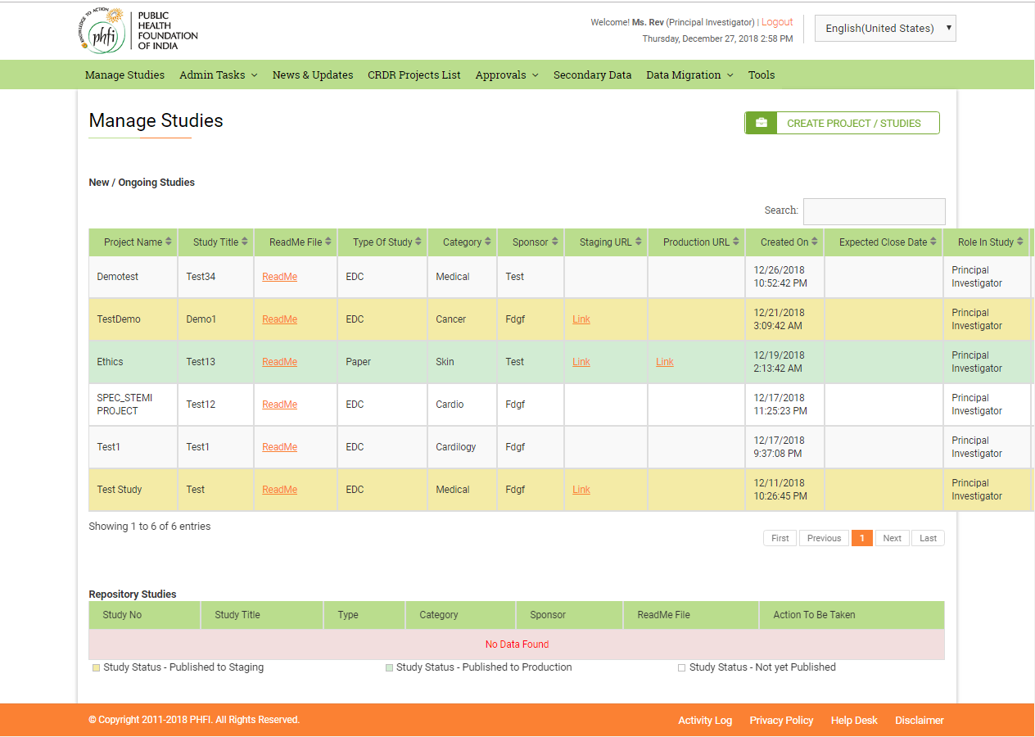

**Figure 02: On load page/Home Page**

## 3.1 Manage Studies

On clicking the “Manage Studies” menu user will be displayed with the study dashboard. If there are no studies, “There are No Studies Found” message appears on the screen.

### 3.1.1New/Ongoing Studies

The study list grid contains following details,

* **Project Name**: Project name details are displayed here.
* **Study title**: Study title given while creating the study is displayed here.
* **Readme file**: Uploaded readme files are available in this column. On clicking ReadMe hyper link file opens.
* **Type of Study**: Type (EDC/Paper) of study is displayed.
* **Category**: Study category is displayed here.
* **Sponsor**: Sponsor related details are available here.
* **Staging URL**: On publishing the study to staging, a link appears in this column. On clicking on the Link, user will be navigated to the study in staging. This URL is used for testing and training purposes.
* **Production URL**: On publishing the study to Production, a link appears in this column. On clicking on the link, user will be navigated to study in production. This URL is used for live activities.
* **Created On**: Study created date will appear.
* **Expected Close date**: The Expected close date given while study creation is displayed here.
* **Role in Study**: Role of the user specific to that study are displayed here.
* **Actions**: Permission allocated to perform various actions related Status is displayed here.
* **Publish to Staging**: On clicking the publish icon, the study is published for staging.
* **Publish to Production**: On clicking the publish icon, the study is published to production.
* **Edit( Icon**): On clicking the edit icon, system allows user to edit the create study related details. Once the study is published, user cannot edit the details.
* **Configure (- Icon)** : On clicking the configure icon, system allows user to configure the CRFs.
* **Backup (- icon)** : On clicking the backup icon, a pop up appears in two sections for staging and production. User can provide the reasons and click on “Create Backup” button.
* **Type** : This column has **DMS/Access Study** link which navigates user to the Study page where user can upload documents.

### 3.1.2 Repository Studies

Repository Studies contain the access to the studies which are closed and moved to public. The user can access these studies to derive the reports and other analytical data.

Repository Study grid has following the following the details

* **Study No**: Study number related details.
* **Study Title**: Study title related details are given here.
* **Type**: Type of studies (EDC/Paper) are given here.
* **Category**: Category specified while study creation is displayed here.
* **Sponsor**: Sponsor related details are given here.
* **Readme file**: The read me file is available in this column.
* Actions to be taken: Access to the study is provided through this column. On clicking Access Study, user shall be enabled to access study details with a specific modules, to derive the reports and other data. The Access Study is described in detailed under “**Repository Studies_Acess Study**” section in same manual.

A navigation bar is available to take through page wise, at the bottom of each grid table.

At the bottom of the page color codes related to Study Status are indicated.

1. Orange indicates –Published to staging
2. Blue indicates- Published to production
3. White indicates- Not yet published.

### 3.1.3Create Project

In create project page, user can provide the details related to “Project code” and “Project Name”. On clicking Submit button a new project is created. System displays the following message. “**The project has been created successfully. To create a study for this project, click on Create Study**”.

Project Code: Alphanumeric 10 characters

Project Name: Alphanumeric

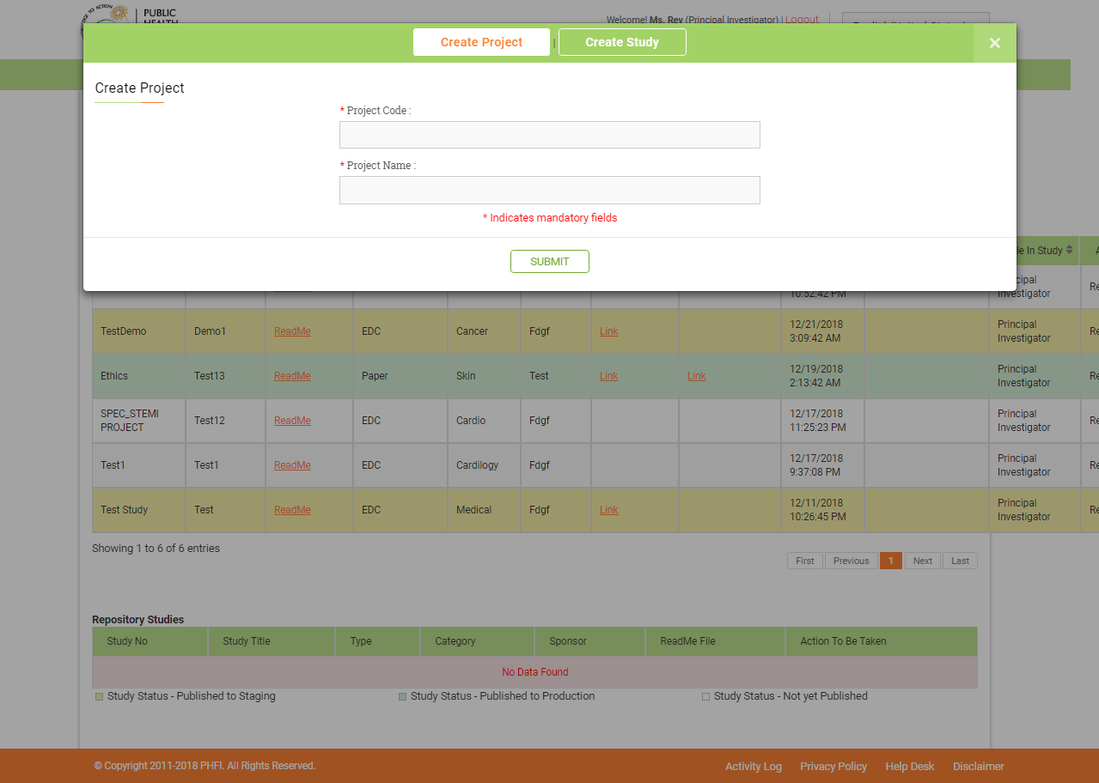

**Figure 03: Create Project Page**

### 3.1.4Create Study

Using create study menu, user creates a new study, filling the required details.

* **Assign project: (**Drop down) All the projects created using Create Project menu are created here.
* **Assign PI**:(**Dropdown**) Already created Principal Investigator role users will be displayed in this drop down.
* **Project Code**: (Alpha Numeric Text box)) Desired title for the study should be typed in this text box.
* **Description Objective of the Study**: (Alpha Numeric Text box) The detailed description of the study can be typed in this text box.
* **Readme Text File**: (Browse button) Desired files from the system can be chosen and uploaded.
* **Type of Study: (**Radio button) The type of study EDC or Paper can be selected.
* **Category: (Alphanumeric Text Box)**
* **Sponsor Name: (Alphanumeric Text box)**
* **Staging URL: (Alphanumeric Textbox)** Staging URL allows user to decide the URL for the testing and validation purposes. The Studies are first published to staging, validated. All the testing and verification activity is carried out here.
* **Production URL: (Alphanumeric Text box**) Production URL allows user to decide the URL for a study to use throughout. Production URLs are used for Live projects.
* **Date Format**: (**Drop down**) Standard date formats are listed out in this drop down and required format can be selected.
* **Study Metadata**: (Alphanumeric)
* **Expected End data**: (Date Picker)
* **eCRF other than in English: (Radio button)** All the other languages in which eCRFs can be viewed are listed down here. User can select required languages. The languages selected here will be available for selection at Multilingual CRF module.
* On Submission a new Study will be created and listed down in study grid.

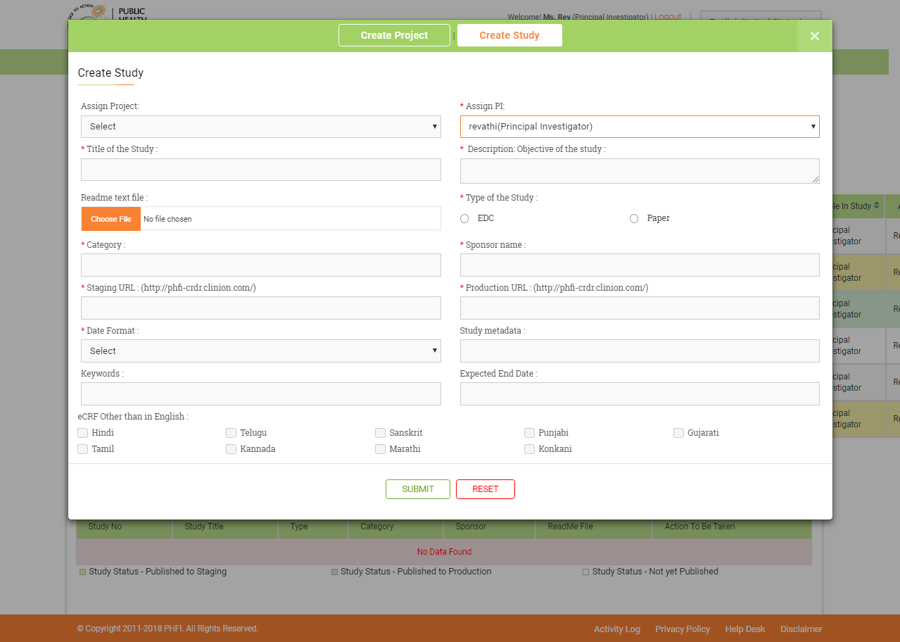

**Figure 04 : Create Study Page**

### 3.1.5Configure Study

On clicking the Configure icon, a pop up with two options to select “Copy from Global library” and “Create new eCRF” will appear. User can select the desired option.

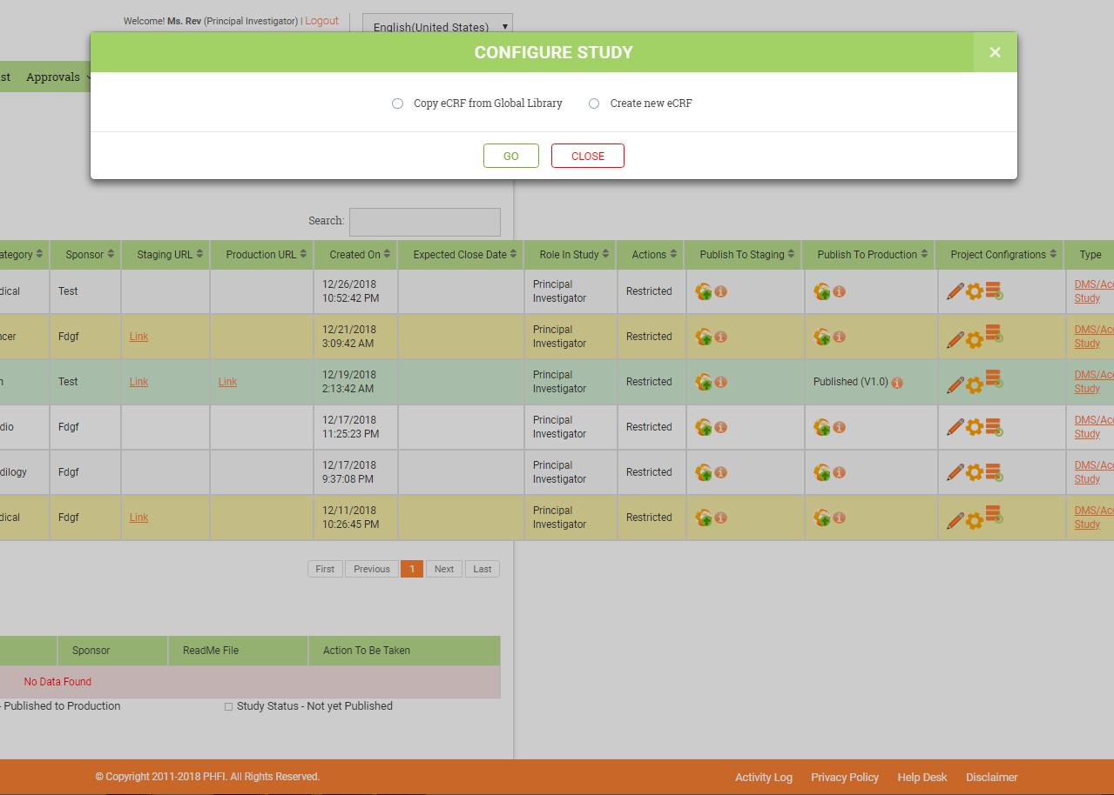

**Figure 05 : Configure Study Page**

### 3.1.6 Copy eCRf from Global Library

All the CRFs published for production will be available for copying from Global library. On choosing this option, user will be navigated to Copy study page.

* In copy study page, user will have option to select the “Study Category” either Paper or CDM from Study category drop down.
* List of studies, will be displayed in tabular format. The study table grid contains details such as “Study Name”, “Title”, “Type” and View Study(Link) and Copy Study(Link).
* View Study (Link): On clicking this link, a pop up window with First page details will appear on the screen. All other pages can be navigated and viewed.
* Copy Study(Link): On clicking this link, a confirmation pop up with a message “Are you sure you want to copy this study?” will appear.

1. On clicking OK, complete study is copied to current study.
2. By default, first page of first visit will appear on screen.
3. Additional visits/ pages/panel can be added and managed through navigation menu.
4. All the rules applicable for the study copied from global library, will be applicable to the newly created study.
5. User can add Rules/Conditional branching/code lists to the copied panels and newly created panels. User can also delete copied rules/conditional branching/code lists if required.

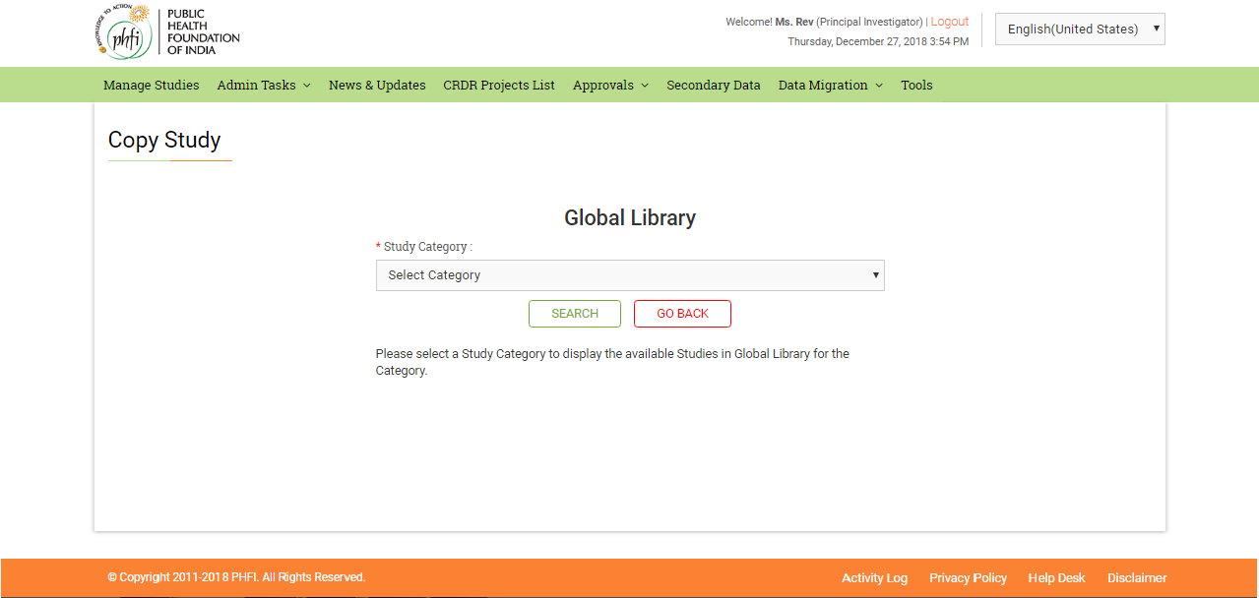

**Figure 06: Copy Study Page**

### 3.1.7Create New eCRF

On choosing “Create new eCRF” option and clicking on GO button, user will be navigated to Configure study page. Using options in this page user can create Visits, Pages, Panels, Code lists, Conditional branching and Protocol Header. All these can be managed using the Navigation bar at the left hand side of the page.

If there are no configurations done, “Study is not yet configured. Please create Visits/Pages from navigation menu” message will be displayed on the screen.

Using the Navigation menu on the left Visits /Pages can be managed. On the right menus to manage Panels, Code lists, Conditional branching and Protocol header are available.

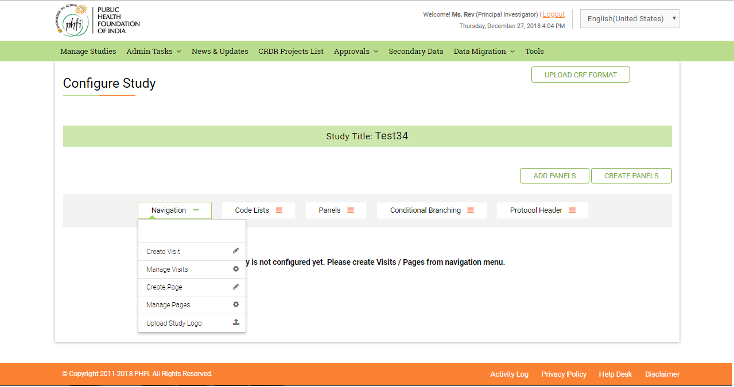

**Figure 07: Configure Study**

### 3.1.8Left Navigation menus

#### Create Visits:

Create Visits option can be accessed from left navigation bar. On clicking on the “Create Visit” option a pop up page appears with details mentioned below.

* **Visit Name**: (Alpha Numeric Text box) (Mandatory) Visit name details are provided here.
* **Description**: (Alpha Numeric Text box) (Mandatory) Visit description will be provided here.
* **Annotation Code**: (Alphanumeric Textbox) (Mandatory)
* **Parent Visit**: (Drop down) (Optional) Previously created Visits will appear here in this drop down. For the first visit this drop down will be empty.
* **Is global Visit**: (check box) (Optional)
* **Is Recurring Visit**: (Check box) (Optional)
* **Is Prescreening Visit**: (check box) (Optional)

On clicking the Save button, all the details entered will be saved and a new visit will be created. “Visit Created successfully. Please Click here to add pages” message appears on the screen. The Click here button should navigate the user to “Create Page” page.

The visit can be seen listed in the Navigation bar.

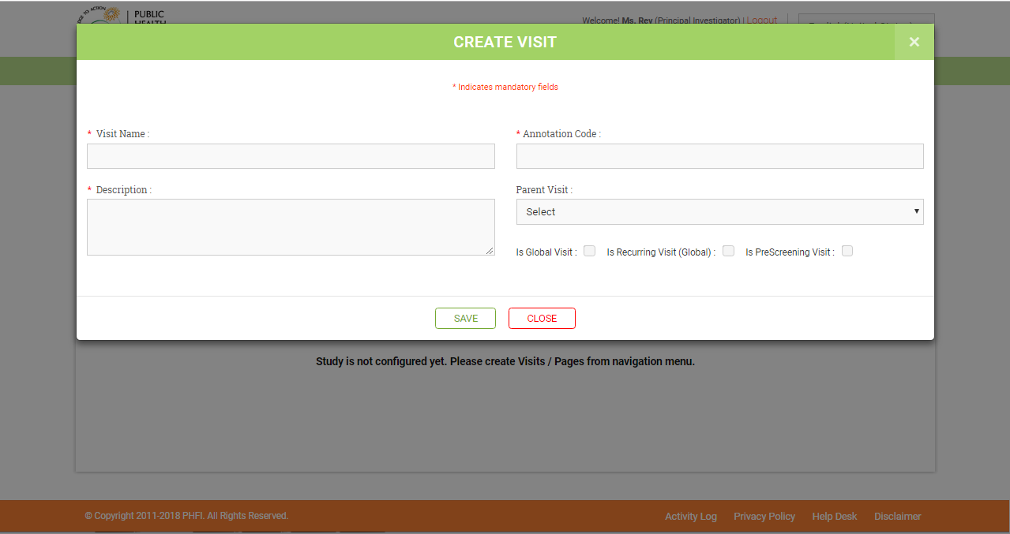

**Figure 08: Create Visit Page**

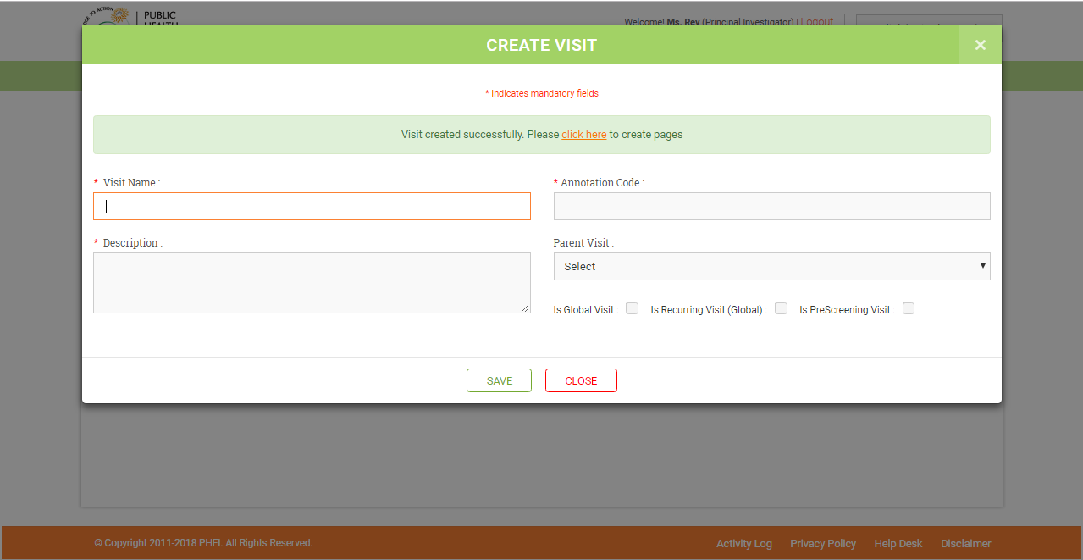

**Figure 09: Create Visit Page**

#### Manage Visits

Manage Visits option can be accessed from the Navigation bar. On clicking Manage Visits option, user is navigated to a page following details related to Visits. If no visits are available, ‘Visits not available’ message is displayed.

If visits are available, the following fields are displayed

* S. No
* **Visit name**: Displays visits name along with a tree view icon. When clicked on the tree view icon, all the pages in respective Visit will be displayed.
* **Description:** Displays the Visit description.
* **Parent Visit:** Displays parent visit details, if exist.
* **Visit Order (Editable Text box):** User can change the order of the visit and click on update button.
* **Is Global:** Displays Yes/No
* **Is Recurring Visit:** Displays Yes/No
* **Edit Icon:** When clicked, user is navigated to ‘Create /Modify Visit” page where user can update the visit details and click on save button. A ‘click here to add pages’ option is available for the user to add pages to the respective visit. At the bottom of this page, the visits are presented in a table, in which one can see the serial number, page name, page order (which can be edited), page description, menu display name, annotation code, page instructions and investigator verified. There’s an ‘Update’ button, at the bottom of the page.
* Delete (icon)- when clicked, a message “Are you sure, you want to delete” is displayed. The user clicks on ’OK’ button to delete the visit. ‘Visit deleted Successfully’ message is displayed.
* **Color Coding**: The color coding legends are displayed on the bottom of the page

1. If the Visit has pages, it is shown in green color-Assigned pages.
2. If visit does not contain pages, the visit is shown in orange color- Unassigned pages.

#### Create Page

On clicking the “create Page” option from left Navigation bar, system displays a pop up page to fill up the details required to create a page.

* **Page Name**: (Alphanumeric Text box) (Mandatory)
* **Page Description**: (Alphanumeric Textbox) (Optional)
* **Menu display Name**: (Alphanumeric Textbox) (Mandatory)
* **Annotation Code**: (Alphanumeric Textbox) (Mandatory)
* **Page Instructions**: (Text box)
* **Is Investigator Verification required**: (Check box) (Optional)
* **Is Global Page**: (Check box) (Optional)

On clicking the save button, the details related to page are saved and a new page is created. “Page created successfully. Please click here to add panels” message appears on the screen.

On clicking Click here option, system navigates user to “Create Panel” page.

The created page is listed in navigation bar.

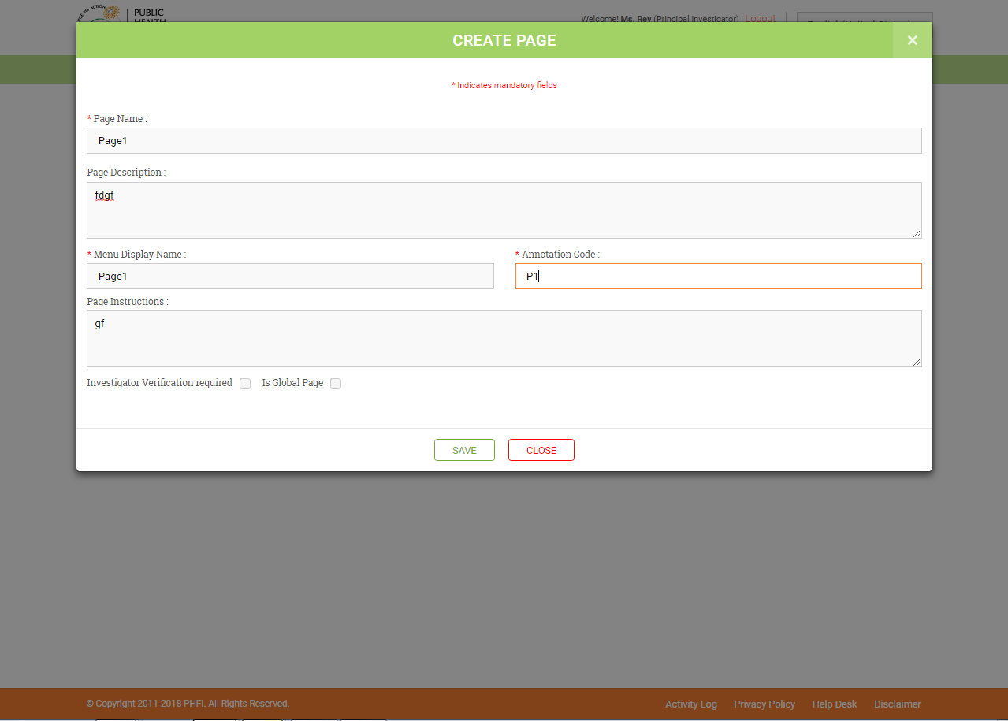

**Figure 10: Create Page**

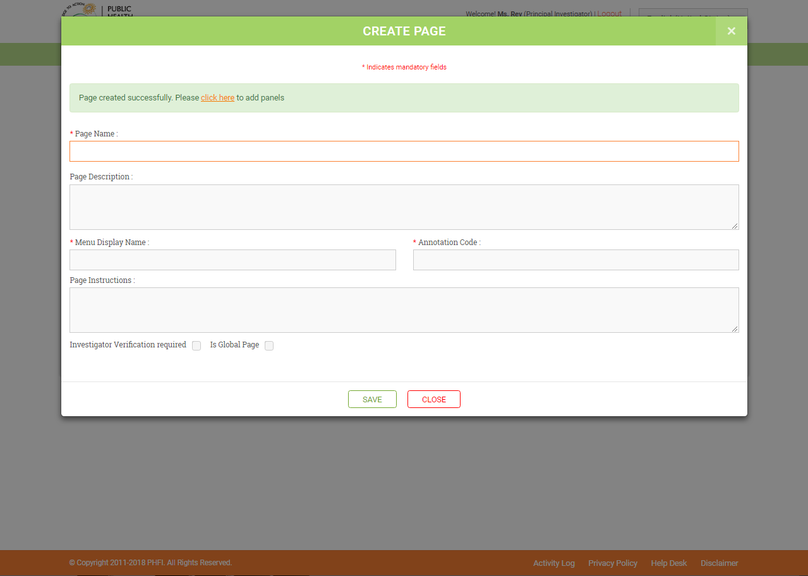

**Figure 11: Create Page**

#### Manage Pages

The manage pages options allows user to edit, delete the already created pages. If there are no pages, a message “Pages are not available” is displayed. If pages are available, the following fields are displayed

* S.no
* **Page Name**: Display the page name
* **Page Description**: description related to that page is displayed here.
* **Menu display name**: Displays the menu name.
* **Annotation Code**: Displays page annotation code.
* **Page Instructions**: Displays page instructions.
* **Manage Panels:** (Icon) when clicked on this, the user is navigated to respective page and is allowed to add panels by clicking on the “Add panels” button. A delete icon is provided on the panel which allows the user to delete the panel. The user can edit the required panel by clicking on the edit icon available beside the delete icon.
* **Edit (icon):** The user can update the details of the visit by clicking on the edit icon. Update/cancel icons are displayed for the respective page in order to update/cancel the edit option for the page.
* **Delete(Icon):** The user can delete the pages by clicking on this icon. If the page is associated with any of the visits in the study, “**The page is associated with some of the Visits in the study. The page will be deleted from all the Visits**’’ message is displayed for the user.
* Color coding (legends) for the page are displayed at the bottom of the page:

1. If the page has panels and if it is assigned to any of the visits, the page is shown in green color.
2. If the page does not contain any panels or it is not assigned to any of the visits, the page is shown in orange color.

### 3.1.9Create Panel

When clicked on Create Panel button, user is navigated to Create/Modify Panel page. The user can create panel in this page.

Create / Modify Panel contains the following fields.

Panel Name (Mandatory)

Annotation Code (Mandatory)

Panel Heading

Panel Layout – contains the following options. By default, Simple panel layout is selected.

Vertical - When vertical panel is selected following fields are displayed.

Select Columns & Rows (Mandatory)

Specify Column Widths (comma separated) (Mandatory)

Vertical Repeat - When vertical repeat panel is selected following fields are displayed.

Select columns (Mandatory)

Specify Column Widths (comma separated) (Mandatory)

The user can select the following options for a panel

Is Screen Failure – This should be checked for the panel, which contains screen failure item.

Is Dropped - This should be checked for the panel, which contains dropped item (for subjects that are to be terminated from the study).

Is Adverse Event - This should be checked for the panel, which contains adverse event term.

Is Concomitant - This should be checked for the panel, which contains concomitant event term.

The user can create the following controls.

Label

Text Box

Radio Button

Check Box

Drop Down

Merge Rows

Merge Columns

The above mentioned controls contains following properties.

Label Text

Display Label Text

Annotation Code

Help Text

Data Type

Max Length

Is Multiline Textbox

Is Mandatory

Align

Is Bold

Has Attachments

Has Notes

Has QRS

Has Multiinput option

No. of Multiinput boxes

Multi input Separator

Multi Textboxes Max length

Is Screen Failure item – To exclude the subject from the study, this check box should be selected and corresponding value need to be specified in the ‘Screen Failure Item Value’ field.

Screen Failure item value – The screen failure item value is specified.

Is Dropped Item - To withdraw the subject from the study, this check box should be selected and corresponding value need to be specified in the ‘Dropped Item Value’ field.

Dropped Item Value – dropped item values is specified.

Is AE term – The user selects this check box for the respective term to perform medical coding for adverse event.

Is Concomitant Term - The user selects this check box for the respective term to perform medical coding for concomitant medication.

Repeat Columns – The user can specify in how many columns the code list should be displayed.

Repeat Direction – The user can specify the direction (vertical/ horizontal) to display code list.

Code list (Dropdown) – All the available code lists in the study are displayed in the drop down.

If Others, Specify Code Value Text – If the user wants a text box displayed when a particular code list is selected, the user specifies the code list value text here.

After creating each data field in a panel, the user must click on update and then proceed with creating the next data field.

Once the panel has been created, the user must click on save button that’s provided at the bottom of the panel creation page.

If the user clicks on ‘Go back’ button without saving the panel, all the changes would be lost.

On clicking on the Go back button, the user would be redirected to the configure study page.

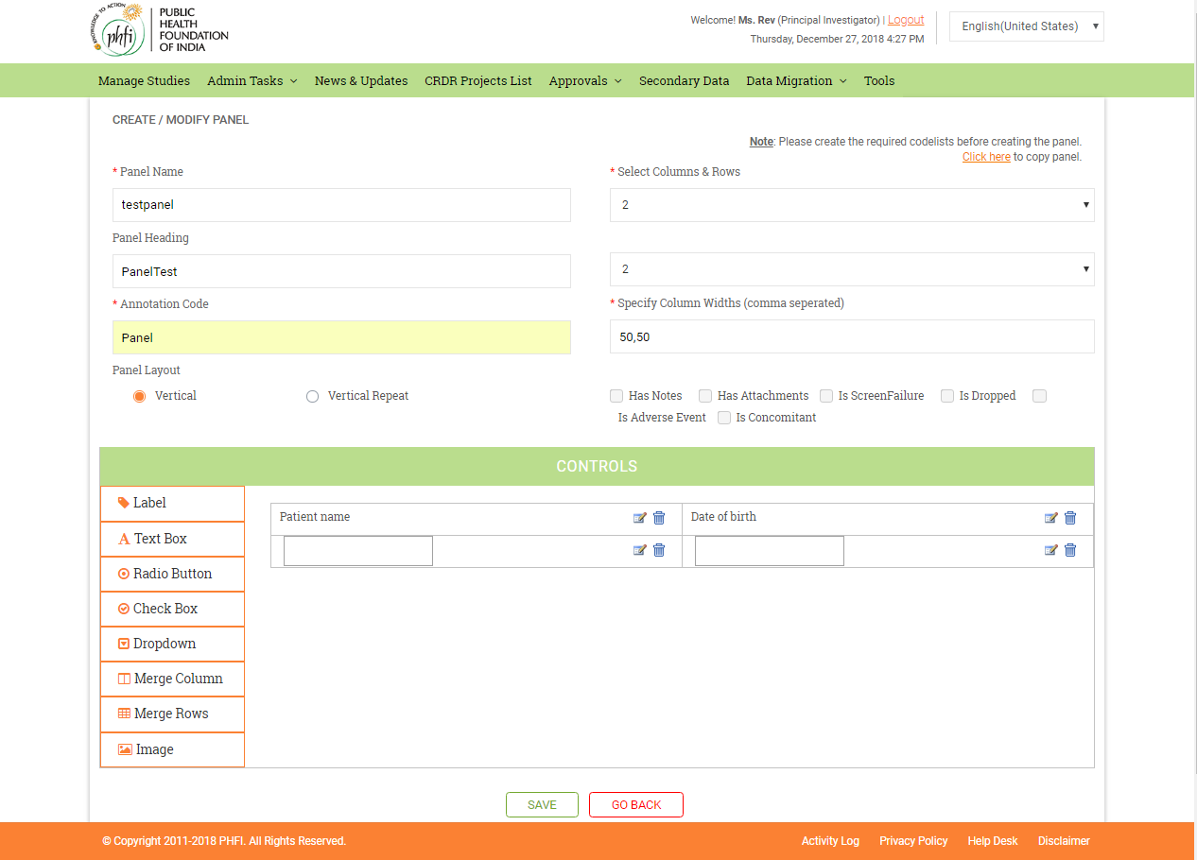

**Figure 12: Create Panel**

#### Steps to be followed to Copy a panel

* A link, “Click here to copy panel” is displayed, on the main Configure Study page, next to create panel button. When the user clicks on the link, a pop-up is displayed with all the available panels in the study. The user can copy panel and can edit it.
* A link, “Copy panel from Global Library” is displayed. When user clicks on the link, the user is navigated to Global Library page. The Global Library page contains the following

Search Panels section where he can search for the “Study Category”, “study” and “Keyword” of the panel.

All the available panels are displayed.

If any of the panels are already available in the current study, those panels selection is disabled.

* If no panel is available, “Currently no panels are available in the study” message is displayed.

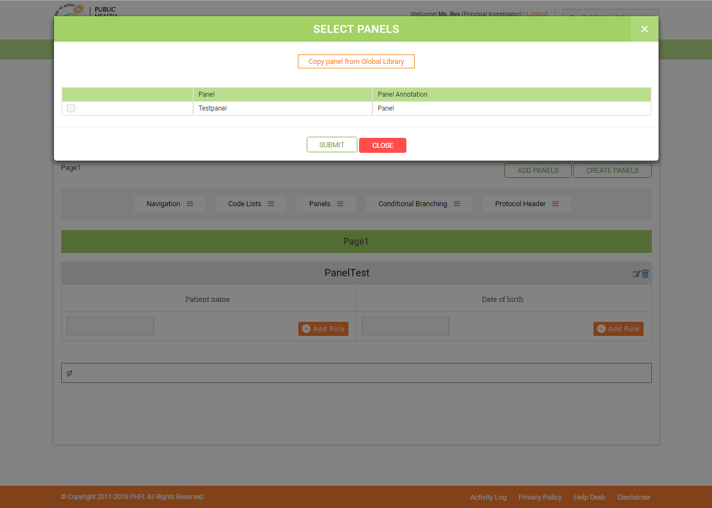

**Figure 12: Select Panel**

#### Add Panel Button

Add Panels option enables the user to add panels, on clicking the option a pop up window to select all th panel swill appear.

* A link to copy panels from global library is displayed.
* If there are no panels in the study, a message “Currently no panels are available in the study. Please click here to create panels” is displayed. When the user clicks on the link, the system navigates the user to Create/Modify panel.
* If the panels are available, the list of panels is displayed. All the panels that are available on the current page will be shown as selected.

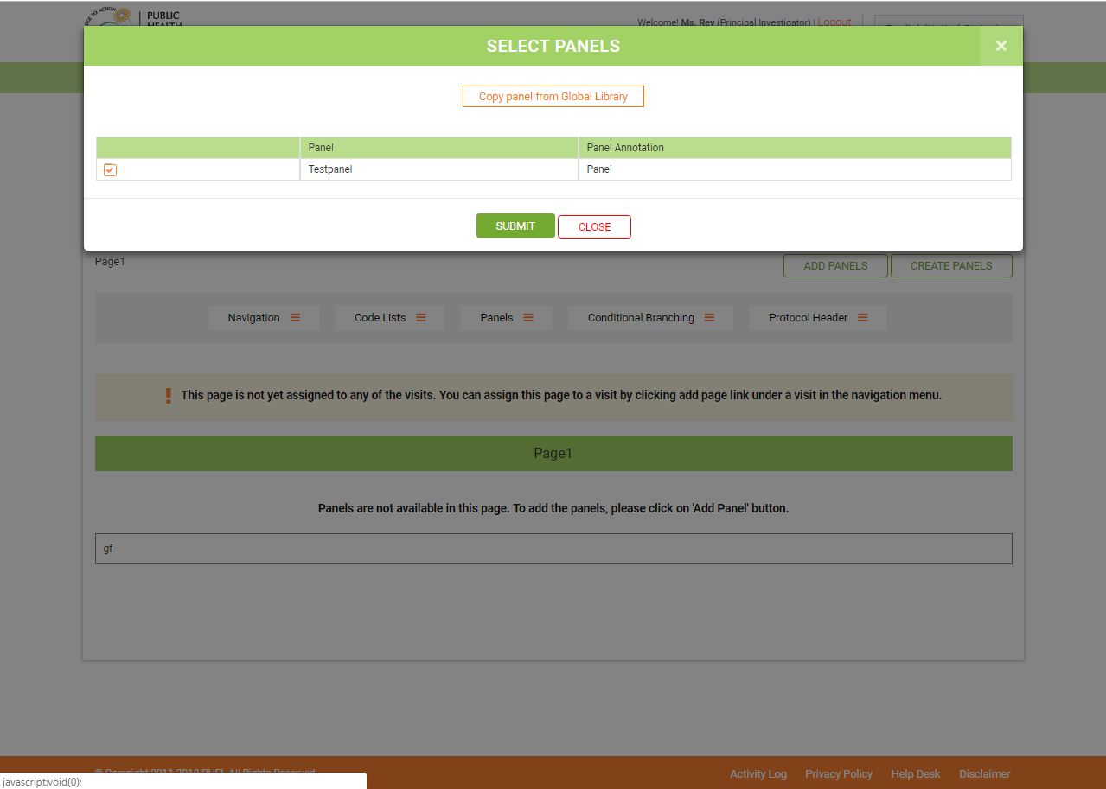

**Figure 13: Select Panel**

#### Right Rules Bar

Displays all the available rules in the page by panel.

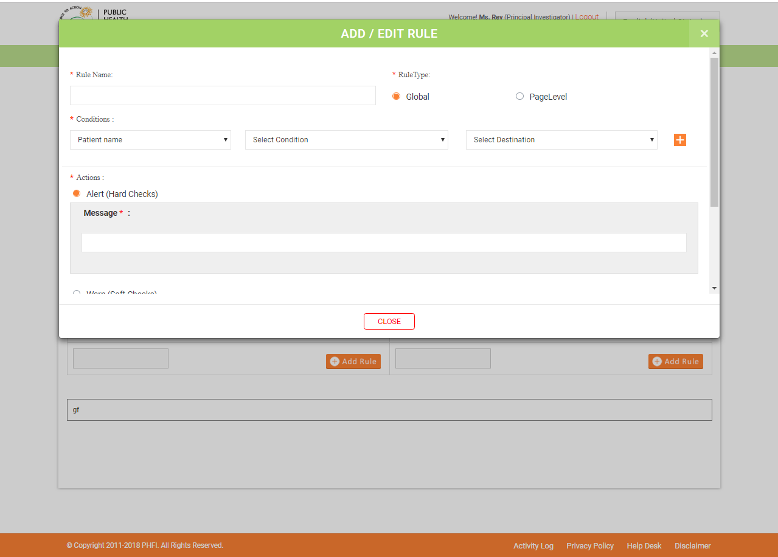

**Figure 14: Add Rule Page**

#### Add Rule

On selecting add rule, the user is directed to the Add/Edit rule page. On this page, the following fields are available

* Rule Name (mandatory)
* Rule Type (mandatory): Global or Page level
* Conditions (Drop-down): The list of panels in Rule Type (mandatory): Global or Page level
* That particular page would be displayed in the dropdown.
* Select Condition (Drop down): This would give the list of options that the user can choose from: Greater than, Greater than or Equal, Less than, Less than or equal, Equal, Not Blank, Is Blank and Is Valid Date format.
* Select Destination (Drop down): The list would contain, Enter text, Enter value, Enter Date, Enter time, Select CRF Field, Insert formula, Subject enrollment date
* Next to select destination is the Add more conditions icon. Once the Add more icon is selected, the Select Condition dropdown would appear wherein you can select AND and OR options, Select Source Field would be the list of panels in the page. Select condition and destination are the same as those mentioned above.

1. In Actions (mandatory): We have three options:
2. Alert (Hard checks): On selecting this, a mandatory message field would be displayed.
3. Warn (Soft checks): On selecting this, mandatory fields of Message, Auto Query Title and Auto Query Description would appear.
4. Populate: On selecting this, Destination field dropdown would be displayed along with a text area. There is an Add conditions option next to the field area. Once this Add icon is selected, Field Formula field would appear with the links, ‘Select field’, ‘Select Pre defined functions’, and ‘Verify formula’.
5. Add Icon: On selecting this, the user is directed to a page wherein the visits in the study are displayed, which on expanding would display the pages and the panels. Users can select any of these icons to set the rule in.
6. Predefined Functions: On selecting this, a page is displayed with the list of functions (age, date diff, Getdate, Year, Month, Day, To Lower, To Upper, ParseInt, Parsefloat, Parse decimal, Length, Contains, Prepopulate).

* At the bottom of the page, there are two options, Save and Reset. On selecting Save, the rule gets saved. On selecting Reset, the entered data would be cleared from all the fields.
* The list of rules created for that particular panel is displayed in a table, at the bottom of the page. In this you can find details related to “S.No”, “Rule Name”, “Rule Type”, “Rule description”, “Edit icon”, “Delete Icon”.
* On clicking the delete icon, on selecting this, a warning message would appear on the screen with the message as, ‘Are you sure, you want to delete’? On selecting yes, the rule would be deleted.

### 3.1.10Right Navigation Menus

Options such as “Panels”, “Code lists”, “Conditional Branching” and “Protocol Header” are available in the right navigation bar.

#### Panels

Panels menu has “Add Panel”, “Create Panel” and “Manage Panel” menus are available.

#### Create Panel

When clicked on this, the user is navigated to create/modify panel page.

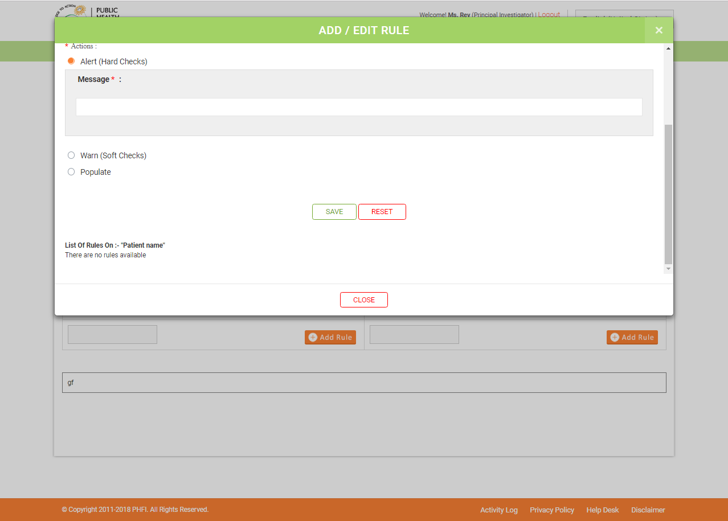

**Figure 15: Add Rule Page**

#### Manage Panel

When clicked on this, the user is navigated to Manage Panels page where he can edit / delete the panel. The following fields are displayed in the page.

* S.No
* Name – Name of the panel is displayed.
* Edit (Icon) – The user clicks on this to navigate to the ‘Create/ Modify panel’ page where he can edit the respective panel.
* Delete (Icon) – The user clicks on this icon in order to delete a panel from the study. A confirmation message, ‘Are you sure you want to delete’ is displayed to the user. When user clicks on ‘OK’, ‘Panel deleted successfully’ message is displayed.

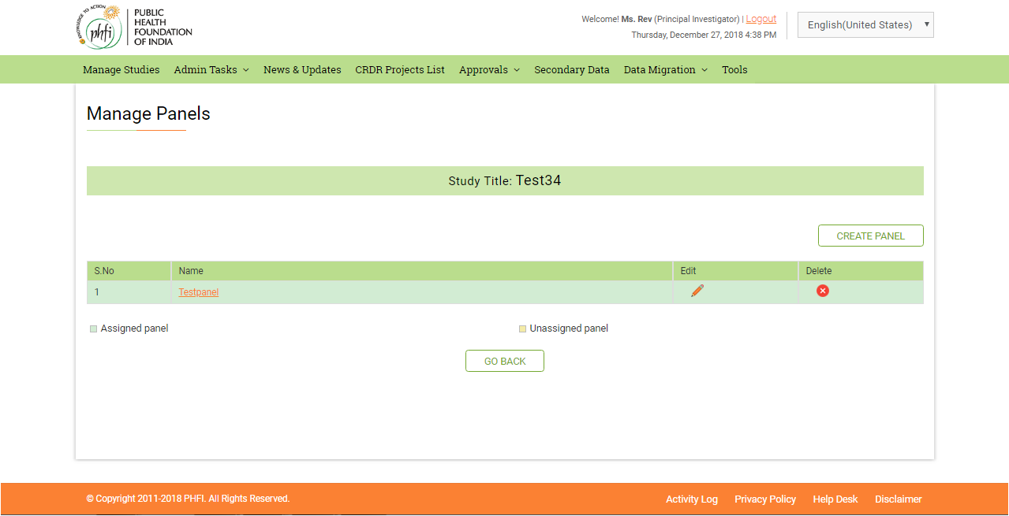

#### CodeLists

Code lists menu available at right pane of the page allows users to configure the required drop downs. User can Create/Manage panels. The following are the fields displayed in the Create / Modify Codelist page

* Codelist Name(mandatory)
* Annotation Code(mandatory)
* Codelist Value(mandatory)
* Codelist Value Text (mandatory)
* Add button – The user clicks on add button to add a value to the code list
* After the required number of values are added, the user clicks on ‘Save’ button. 'Codelist saved successfully' message is shown.

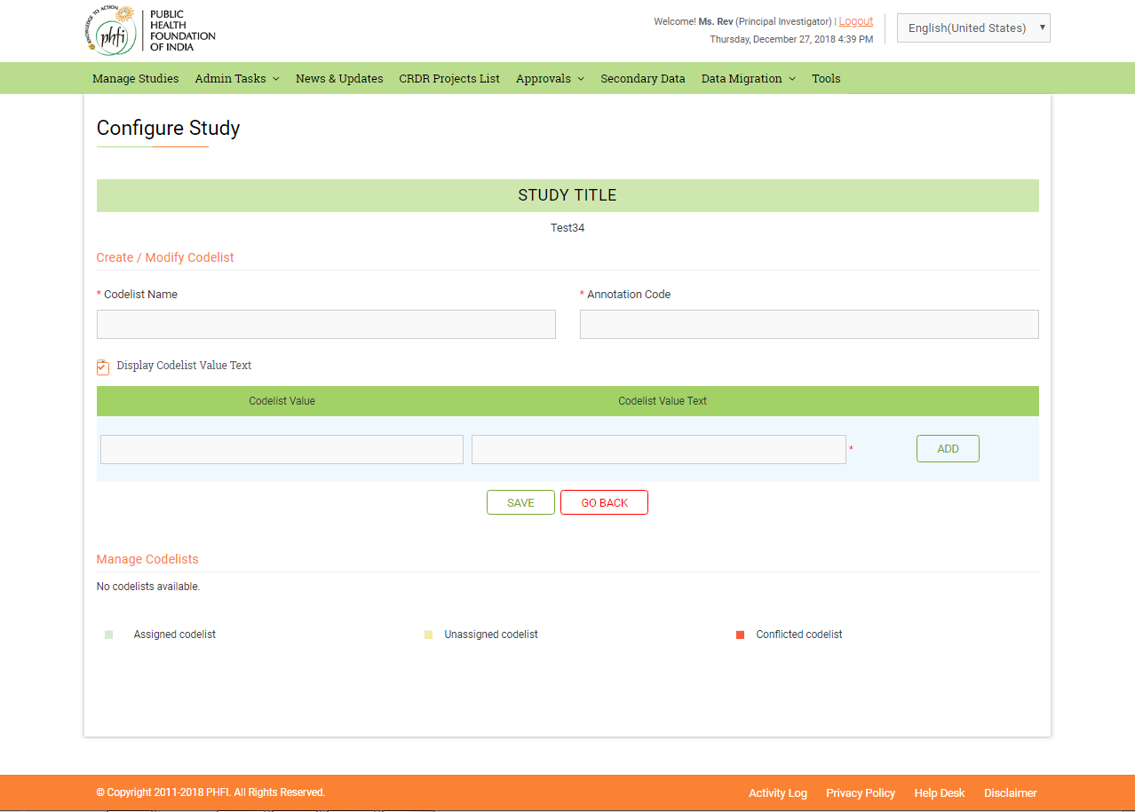

#### Conditional Branching

When clicked on this, “Manage Conditional Branching” link is displayed. The user clicks on ‘Manage Conditional Branching’ link and is navigated to Conditional Branching page where he can configure conditional branching.



The page has the following fields

* Select Visit (Dropdown) – User selects the required visit for which conditional branching needs to be configured
* Select Page (Dropdown) – User selects the required page from the dropdown
* Select Panel (Dropdown) – User selects the required panel from the dropdown
* Select Item (Dropdown) – User selects the required item from the drop down
* Conditional Branching Value Not Null or Value (Text box)
* Select Conditional or Global Branch (Check boxes)
* Conditional Branching Message
* Select Destination Visit (Dropdown) – User selects the desired destination visit from the dropdown
* Select Destination Page (Dropdown) – User selects the desired destination page from the dropdown
* Select Conditional branch option would enable the user to drill down to the panel and items for which the condition needs to be set
* When user clicks on ‘save’ button, 'Conditional Branching added successfully’ message is shown. ‘Reset’ button would clear all the entered data. ‘Go back’ button would redirect the user to the main Configure study page
* All the configured conditional branches for the selected panel are displayed in a grid in the Conditional Branching page. The Conditional Branch grid contains the following fields

1. Panel Name
2. Item Name
3. Conditional Branching Value Type
4. Edit
5. Delete

* Delete (link) - When user clicked on this, a message “Are you sure, you want to delete” is displayed. When user clicked on ok, the added Conditional Branch value is deleted successfully.

### 3.1.11Publish to Staging

By default, publish to staging icon is disabled. The icon is enabled for click action only after the user configured the study.By clicking on the Publish to staging icon, a pop up appears with the following fields

* Comments (Text Area)
* Approved By (text box)
* User Name – By default, the logged in User name is displayed
* Password (Text box)
* Submit (Button)

The user clicks on the submit button to publish the study to staging server . If any of the visits/ pages/ panels/ codelists are unassigned, a message, “Study cannot be published to staging as there are unassigned Visits/ Pages/ Panels/ Codelists in the study.” is displayed to the user. If the study is configured correctly and user clicks on the ‘publish to staging’ icon, the following actions are performed in the backend

* Creation of Database
* Creation of the respective tables
* Creation of Virtual Directory

A link appears in the Studies List in the Staging URL column. When user mouse overs on the link, the URL is displayed in the tool tip. After study is published to staging, if the user makes any configuration changes a red icon blinks beside the configure icon which resembles the changes to the study. An ‘i’ icon is displayed beside the configure icon. When user clicks on the ‘i’ icon, all the published history along with the Version No. 1.0, Comments, Approved By (Username) and Created On (Date and Time) are displayed

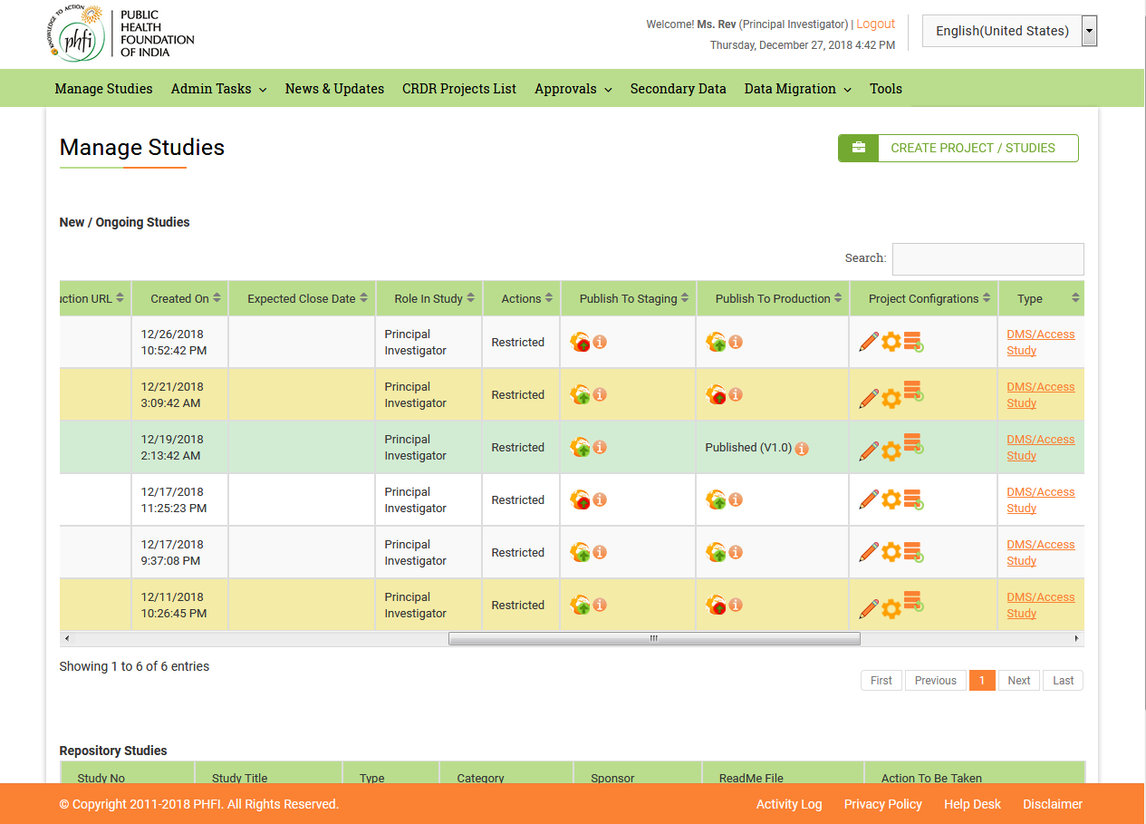

### 3.1.12Publish to Production

By default Publish to production icon is disabled. The icon is enabled for click only after the user published the study to staging. By clicking on the Publish to Production icon, a pop up appears with the following fields

* + Comments (Text Area)
  + Approved By (text box)
  + User Name – By default, the logged in User name is displayed
  + Password (Text box)
  + Submit (Button)

The user clicks on the submit button to publish the study to production server. The username and password are verified at the backend and the study is published. The following actions are performed when the user clicks on the publish icon

* + Creation of Database
  + Restoration of the database on a particular physical path of the backup file name
  + Creation of Virtual Directory
  + Insertion of study related tables in the production database from the staging server database.
  + The study related tables are inserted in the global library in Central Admin Database

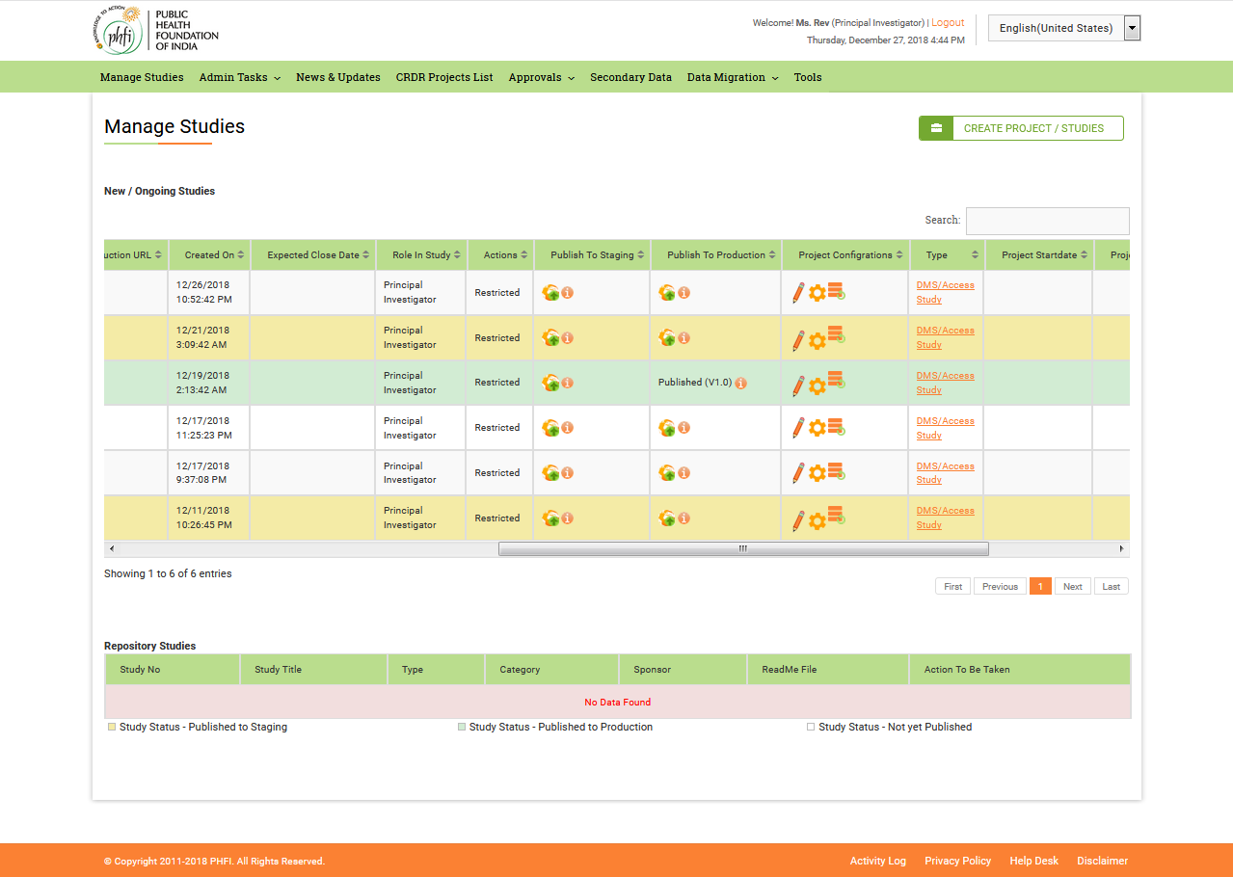

### 3.1.13 Backup

On Clicking on backup icon, user can create backups to the Staging and Production databases. The data files can be stored and used further.

### 3.1.14 Repository Studies_ Access Study

On Clicking Access Study in repository studies table, user shall be enabled with following modules

1. Study Home
2. Standard Reports
3. StandardDashboards
4. DMS
5. Study Reports
6. Study Dashboards

#### Study Home

Study Home is the loading page, on clicking Access Study. The Study home page contains Alerts &Notifications, Recent activities, Most Visited Pages and Active Collaboration dashboards.

If user intends to go back to main page, “Back to manage studies” should be clicked.

**Choosing Required dashboards (** ): Setting Button on the screen helps user to select between required dashboards to be dispalyed on their screen.

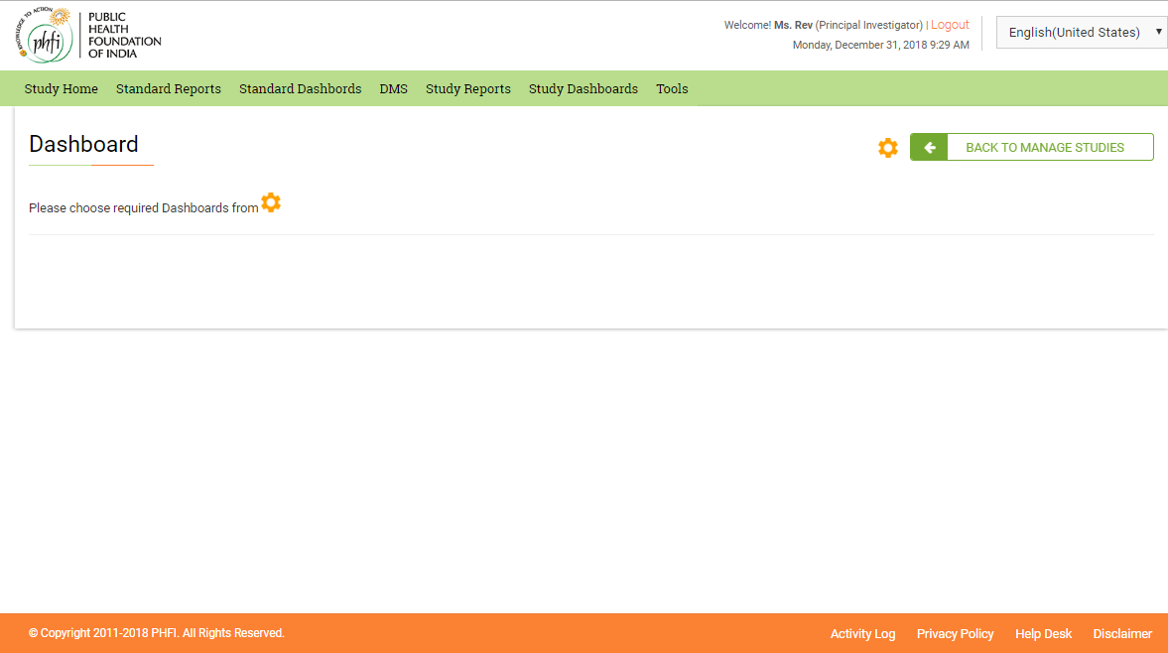

On Clicking on setting icon user is displayed with the list of all the dashboards available and by Activating and deactivating the required dashboard and on clicking “ Assign” the required dashboard shall be assigned on the screen.

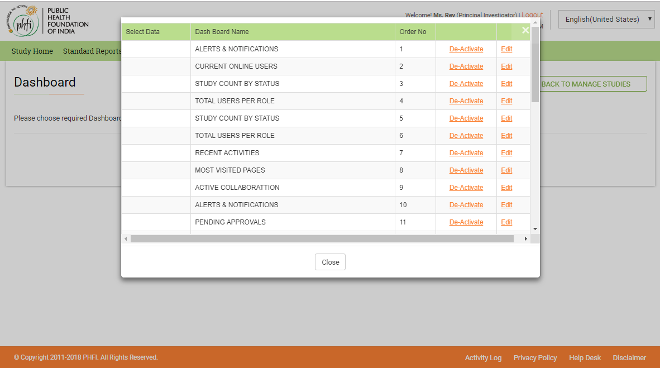

On activating required dashboard and Clicking on “ Assign” button the dashboards shall be assigned on the screen.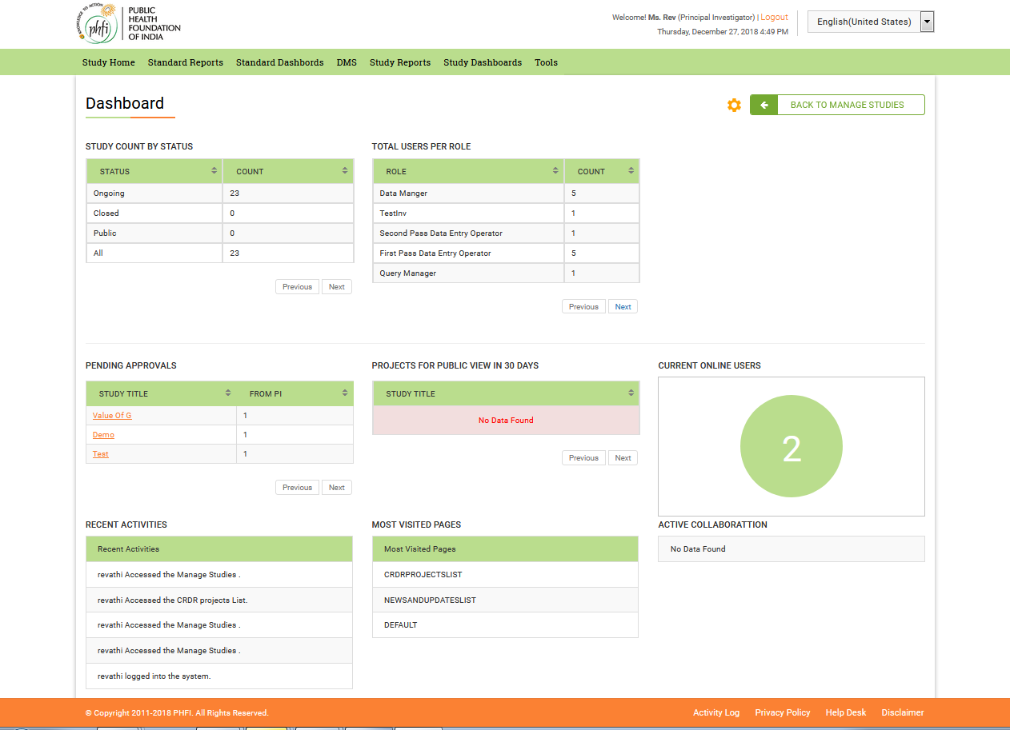

#### Standard Reports

Standard Reports helps user to derive the reports for specific to that study. Two types of Reports are available “**Variable Completeness Report**” and “**Arithmetic Report**”. These reports can be selected from the drop down available at Standard Reports page.

On clicking “Back to Manage Studies” user will be navigated to main page.

Variable Completeness Report

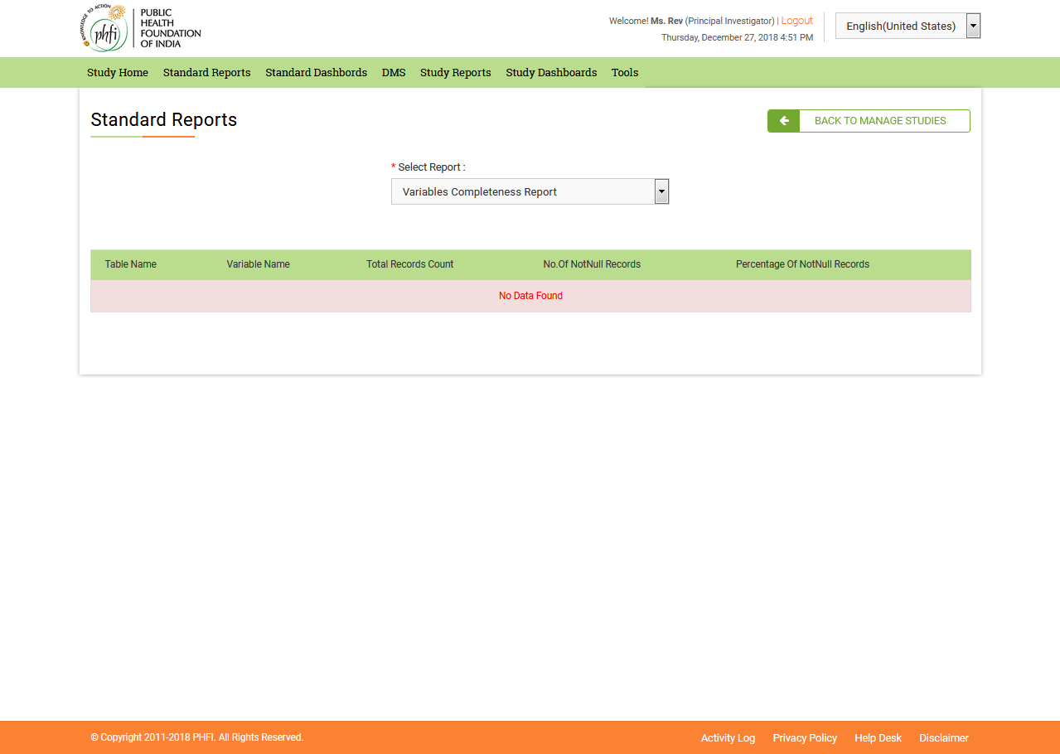

#### DMS

DMS module helps user to manage the uploads of Related documents. Category wise the documents can be uploaded.

Folder and Subfolders can be created using “ Create folder” option.

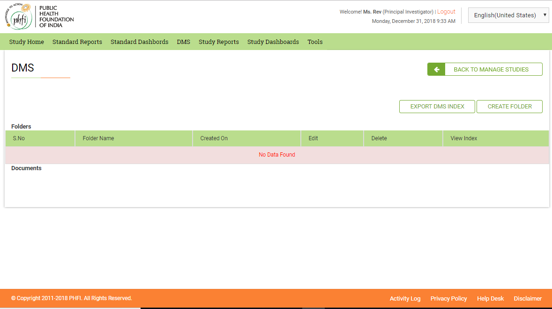

**Create Folder:** On Clicking “Create folder” system displays an option to fill in the “Folder name”.

On submitting the folder name a folder gets created and listed on the screen.

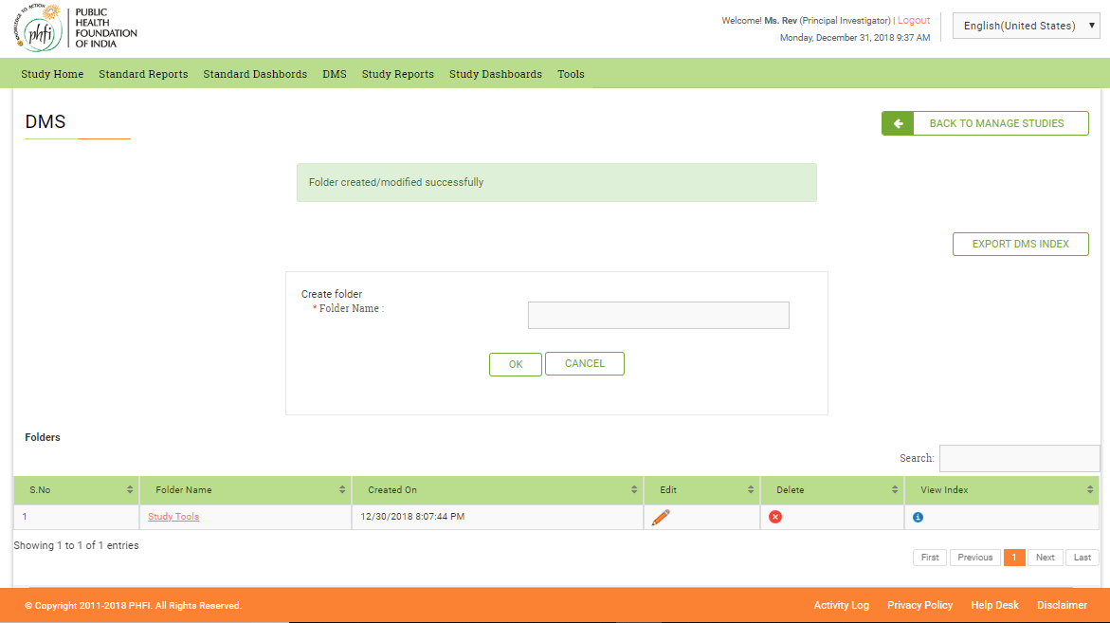

**Creating Sub Folders:** To create a subfolder, Click open the Main Folder and “Create Folder” once again. This helps you to create a Folder with in a folder. The navigation bar on the top helps you to understand where exactly you are in.

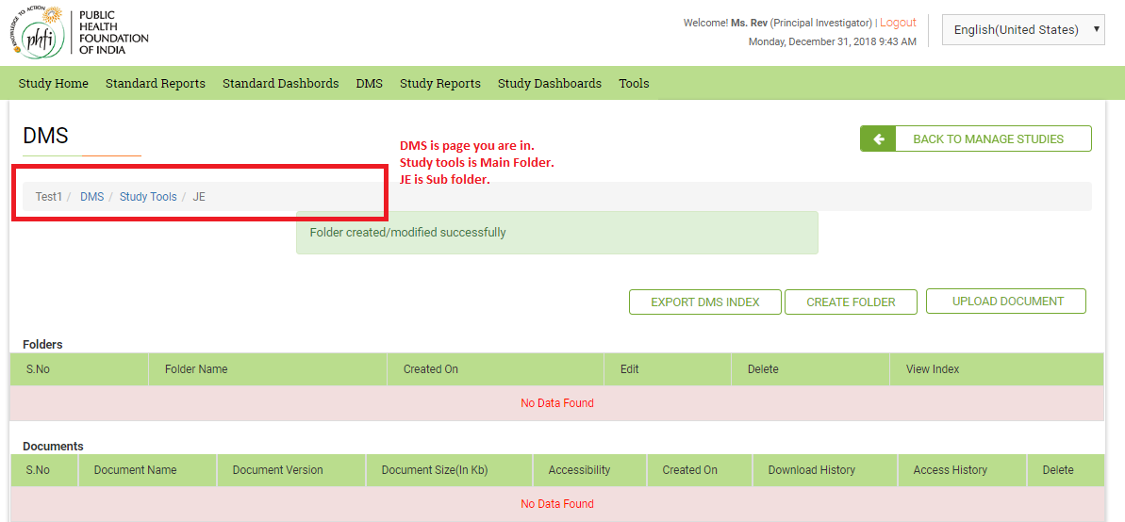

**Delete Folder**: On clicking on delete folder, system deletes the entire folder.

**Upload Document**: On clicking Upload document, a pop up to fill in the details of the documents shall appear. On filling the required details and on clicking “Upload” button, the document will be uploaded in to the selected category.

* You can upload Multiple files at a time. All the document names will automatically picked up system for the multiple files.
* For Single files document name should be specified.
* Multiple versions of documents can be updated.
* If same document is being uploaded twice, system allows user to select between creating a new version or replacing an existing version.

**Table**: The grid table, contains Selection box, Project Code, Study Title, Document name, Uploaded by, Format size, Principal Investigator, Document Version, Download History (View History Link) and Access Provided to details (Access History Link).

View History Link: On clicking View history user will be enabled to view the

Access history: Contains the details of the user who accessed the document.

**Download:**  Required documents can be selected and the

## 3.2 Admin Tasks

### Request for Role

Using this menu PI user can Request any recommended roles to be added to the study. Both Site level as well as trail level users can be added. The request for addition of roles shall be sent to super admin user for approval.

The request can be raised using

* Access Level: A radio button selection to select “Site” or “Trail” level users.
* Role Name: Role recommended
* Recommended permissions: The required permissions for the role to be approved can be given here.

On clicking the Submit button, the Role request will be sent for Approval of the Super admin user. And the details are available in the table below. If user tries to enter the Role that already exists in system, system displays the message “Role Already Exists” up on submission.

### Request for User

Request to create a user is initiated using this menu. Upon approval of Central Admin the user creation will be completed and username will be activated.

To create a user request, the following details need to be submitted

1. Select Role: Drop down to select the required role name.
2. Select Title: drop down menu to select the desired title for the user.
3. Username
4. Name
5. Email Id
6. Mobile number

The later part of page contains two table grids Approved Users and Requested Users.

Approved Users: The user creation requests for which Central Admin approval is completed will be listed here.

Requested Users : The user creation requests for which the Central Admin is still pending will be listed here.

### Roles X Features

On clicking this menu, Principal Investigator user is navigated to Roles X Management page. In this page user can select the features that need to be assigned to the respective role. Role s assignment can be done either by Role or by feature. This page has the following menu options:

* A radio button to select the roles assignment “By role” or “By feature”.
* When user selects roles assignment “**By Role**”, a drop down menu to select the “Role Name” with all the available roles will be available as drop down. On selecting the Role name all the features available in the application will be available for selection. The features can be selected by selecting or deselecting the check boxes. On clicking the” Assign” button features will be assigned to roles.

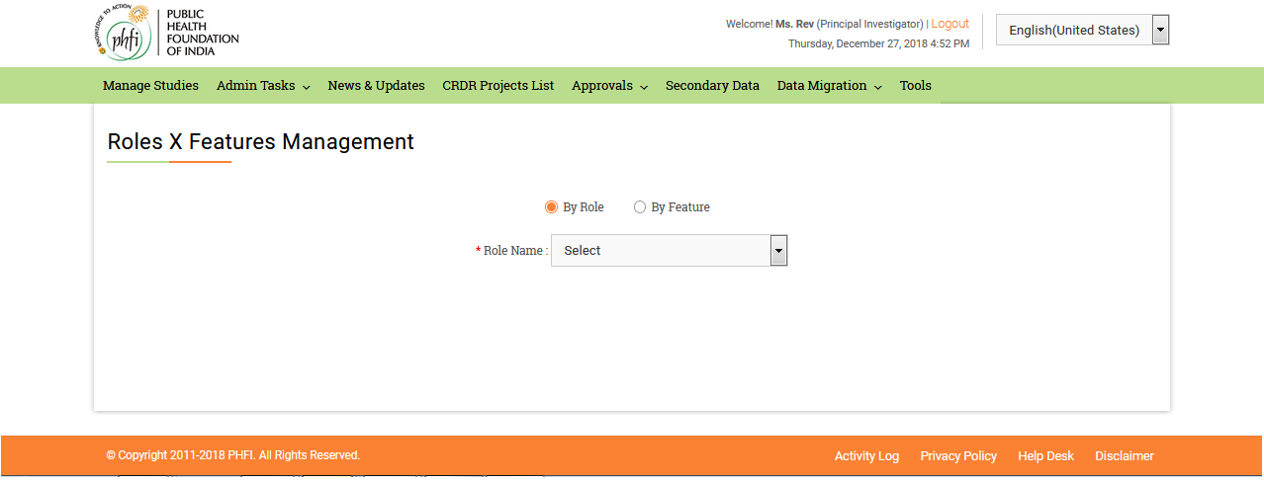

* When PI user selects roles assignment “By Feature” option, all the Features will be available as drop down. Upon selection of required feature all the Roles will be available for selection. Roles for which the feature need to be assigned can be selected by selecting the check boxes. On Clicking the “Assign” button, the features will be assigned to roles.

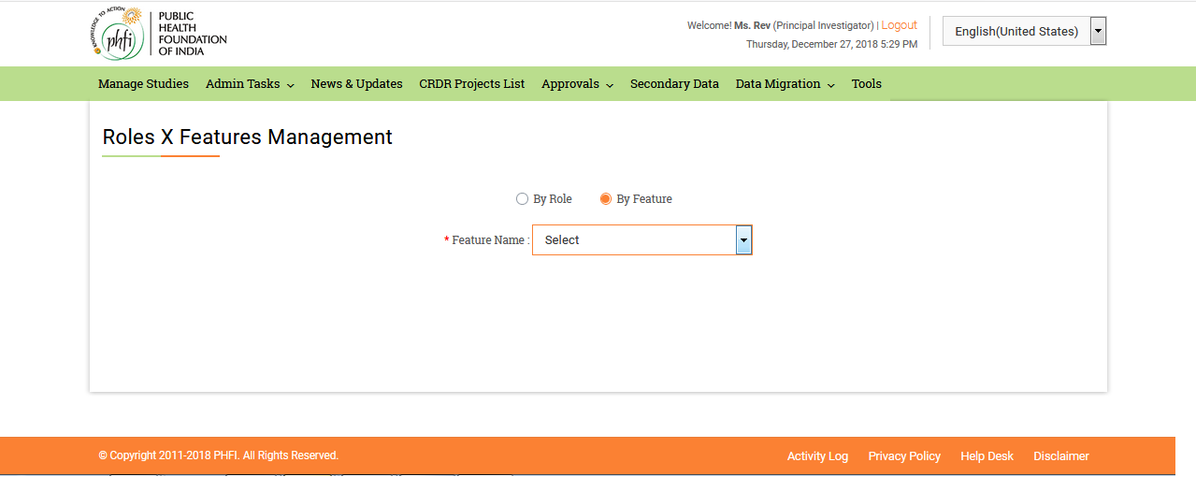

### Roles X Actions

Principal Investigator user can assign actions to required role. Role name dropdown is displayed. User selects the required role. All the features available for that role will be displayed. User clicks on the respective feature and enable the required action to be performed.

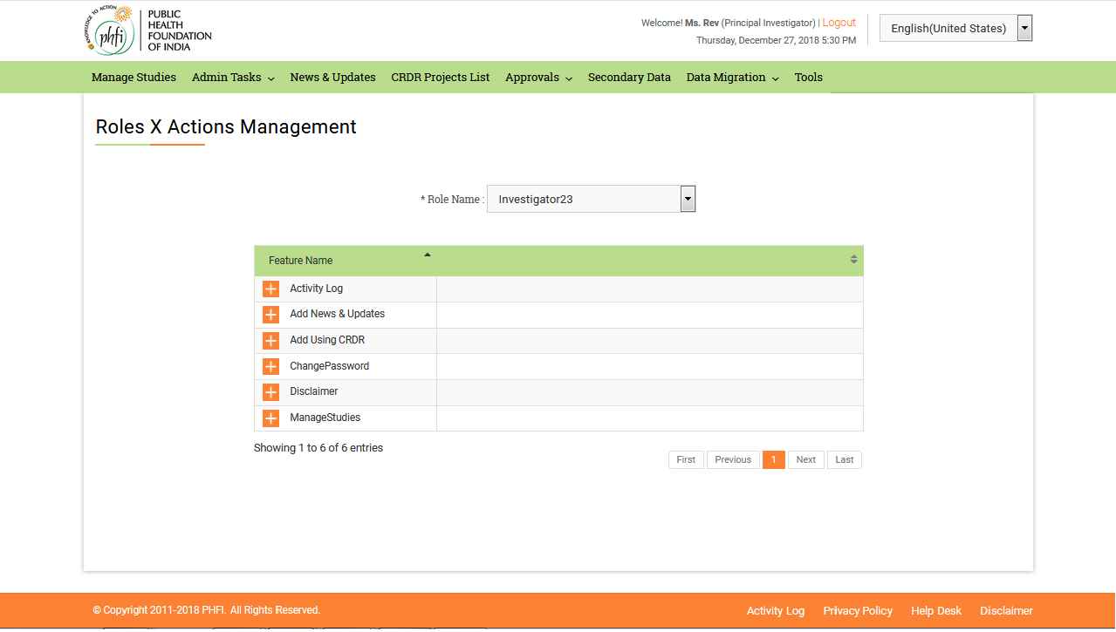

### User Management Permissions

Principal Investigator user can allot permissions to Users to manage other roles using this menu. On clicking User Management Permissions user will be displayed with a page, to select the required Roles. On selecting the required role from dropdown, a list of roles for selection will be displayed. User selects the required roles, and clicks on “Assign” button. “Roles assigned to selected role” message is displayed.

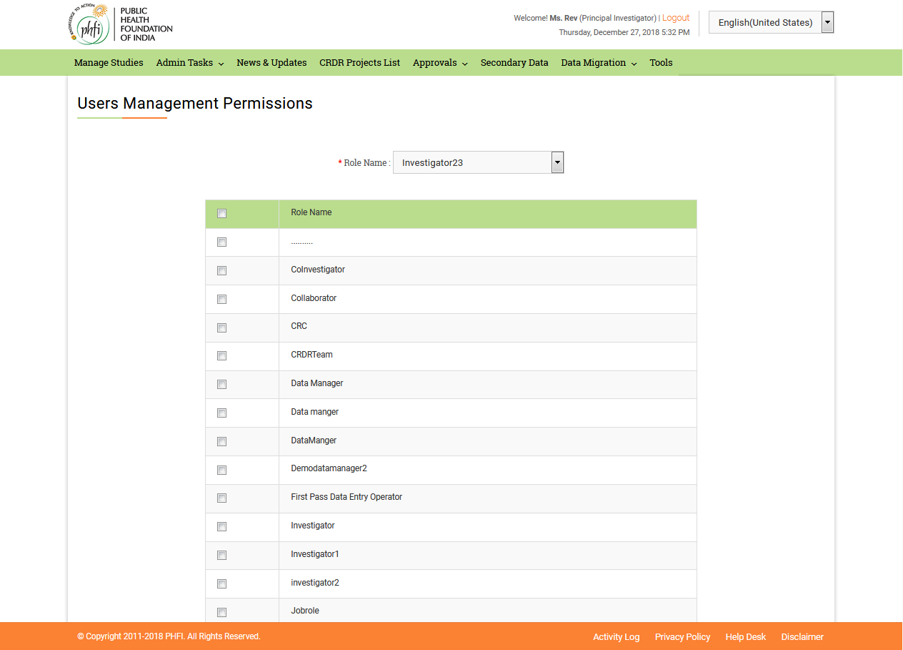

### Email SMPT Configuration

Principal Investigator user provides the details such as “SMPT address”, “Username”, “Password”, “Port number” and “Default admin email address” and clicks on submit button. “Email SMPT configuration details updated successfully” message will be displayed.

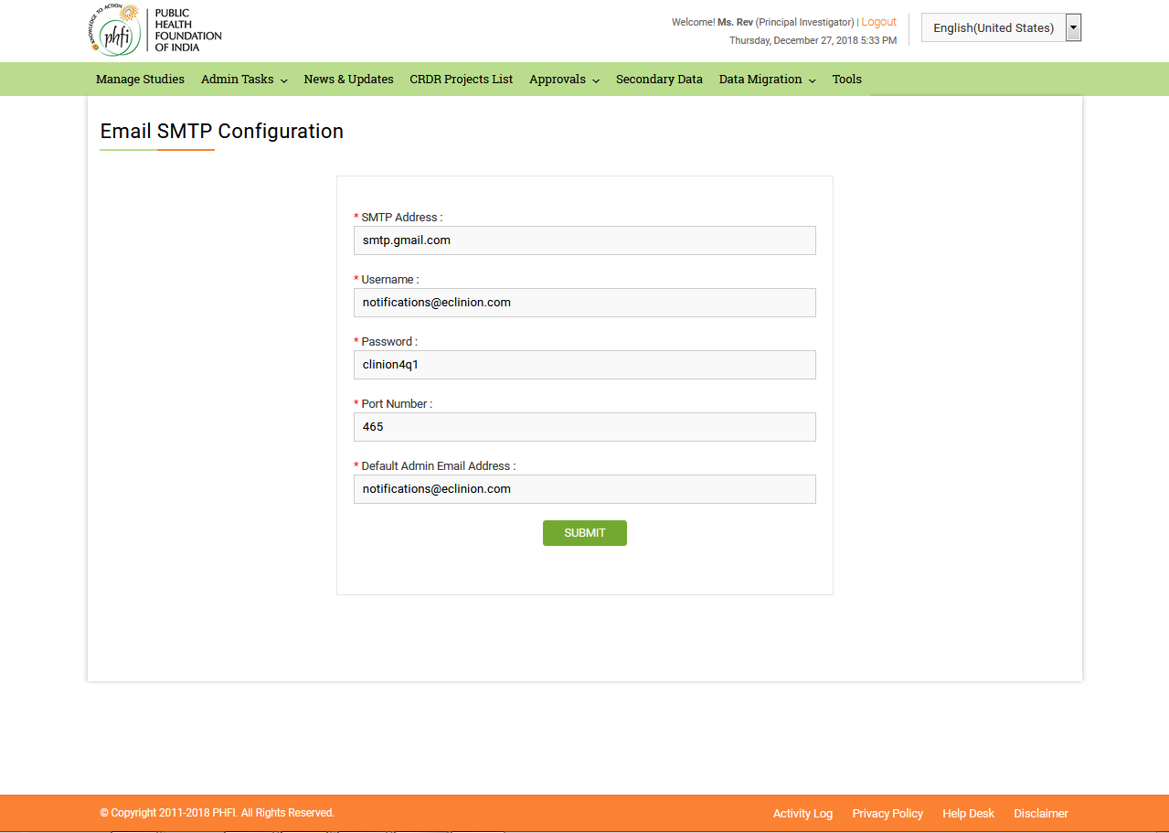

### SMS SMPT Configuration

Principal Investigator user provides SMPT address details and clicks on submit button. ”SMS SMPT configuration details updated successfully” message will be displayed.

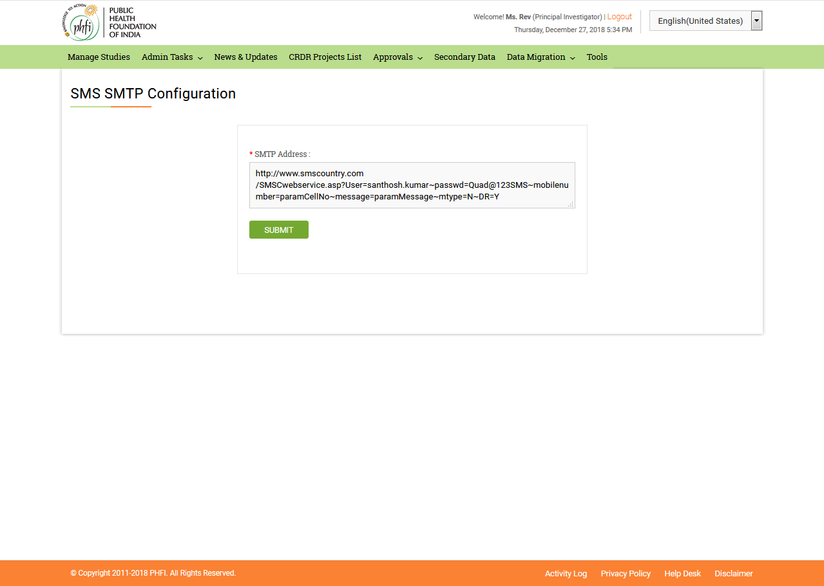

### Change password

Using this menu user will be allowed to change the password details. Super admin user provides Current password, New password and Confirm password details and clicks “Change password” button. ~~“~~Password updated successfully” message appears. On clicking “Reset” button, all the details entered earlier will disappear.

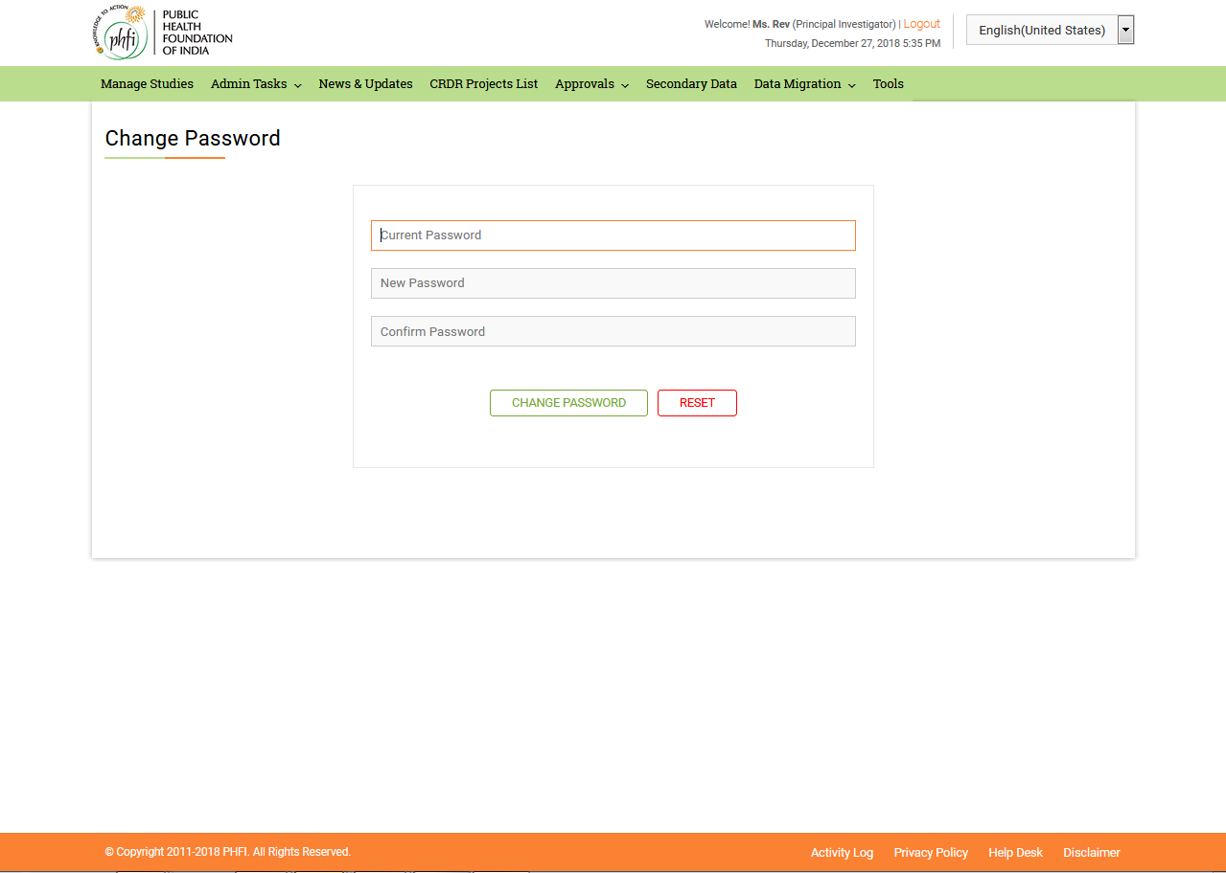

### Using CRDR

Using CRDR menu helps the Super admin to upload the data to be displayed on home page for all th e Users.

* On Opening the menu, options such as “Title”, “Description” and a “Submit” button are available.
* “Description” is a word dialogue box. Text can be entered here in this box and formatted using all the available features.
* On submitting the details, “Data Submitted successfully” message appears on the top of the page.
* The table grid on the bottom of the page contains “No Data Available in Table” message initially. The submitted data details are displayed in the table.
* There is a search box above the table grid.
* A navigation bar is available eat the bottom of the page.

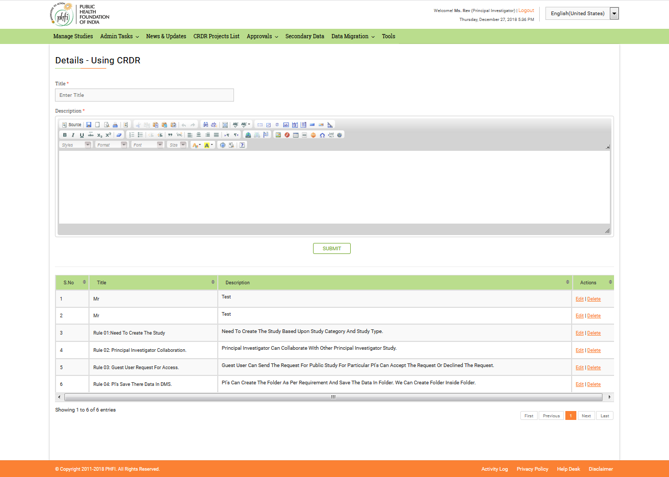

### News & Updates

News and Updates helps the Principal Investigator user to upload the data to be displayed in “News and Updates” column on home page. On loading the page contains following details

* “Title” text box allows user to enter the title for the News to be posted.
* “Description” is a word dialogue box. Text can be entered here in this box and formatted using all the available features.
* On submitting the details, “Data Submitted successfully” message appears on the top of the page.
* The table grid on the bottom of the page contains “No Data Available In Table” message initially. The submitted data details are displayed in the table.
* There is a search box above the table grid.
* A navigation bar is available eat the bottom of the page. 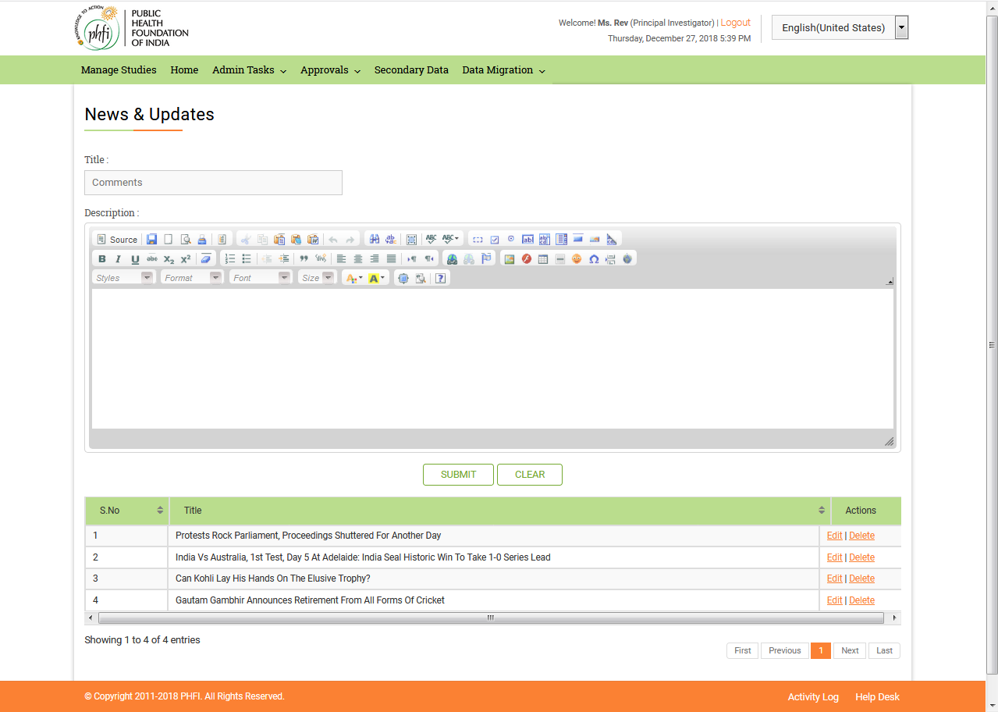

### Upload Home page Images

Home page Images Upload page contains all the that can be uploaded on the Home page. User can Upload the files from system using “Upload Images” choose file option.

* Uploaded files will be available in the list below.
* A search box is available on the top of the table grid.
* An image required to be uploaded can be selected and on clicking Upload option the same will be available on Home page.

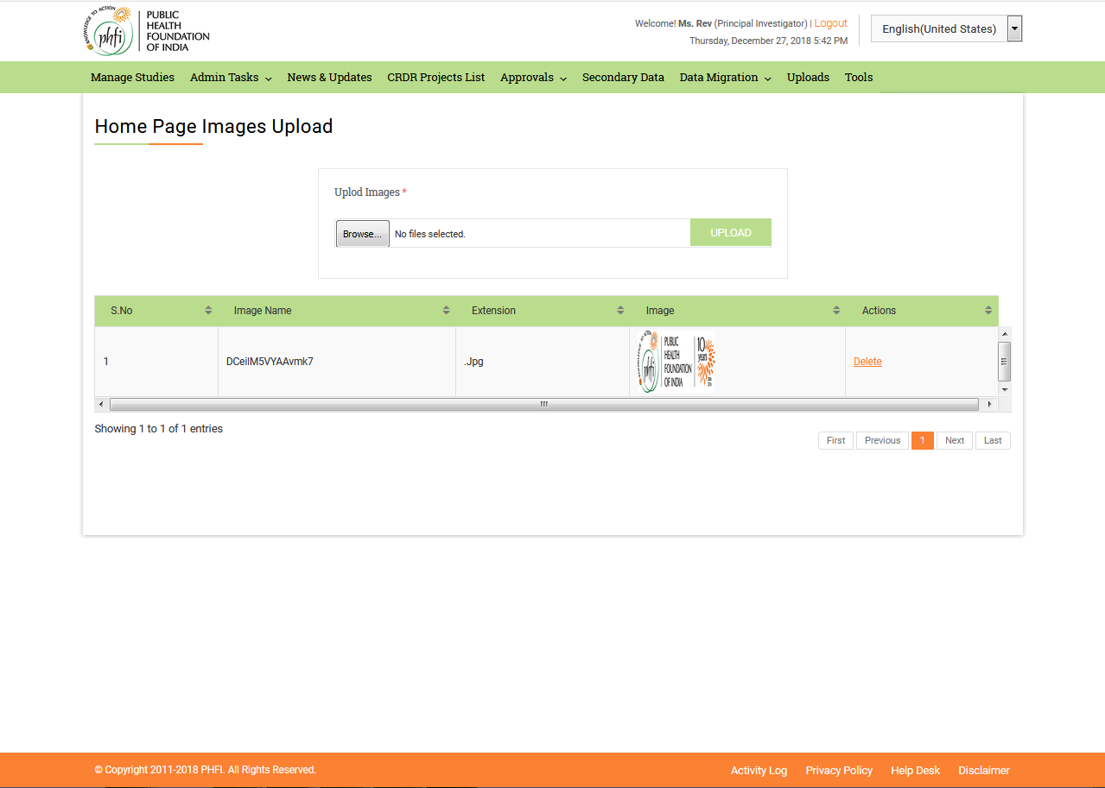

## 3.3 News &Updates

On clicking this menu, all the news updates uploaded can be viewed. The News feed is given by Super admin user and the latest News fed are displayed on top. All the Scientific related and Non Scientific News and updates are available in this module. Different News updates are displayed in different sections with a numbering for each. Each section can be Expanded and collapsed to view the details in it. On load the top News section is displayed open, and the further sections can be expanded as per requirement.

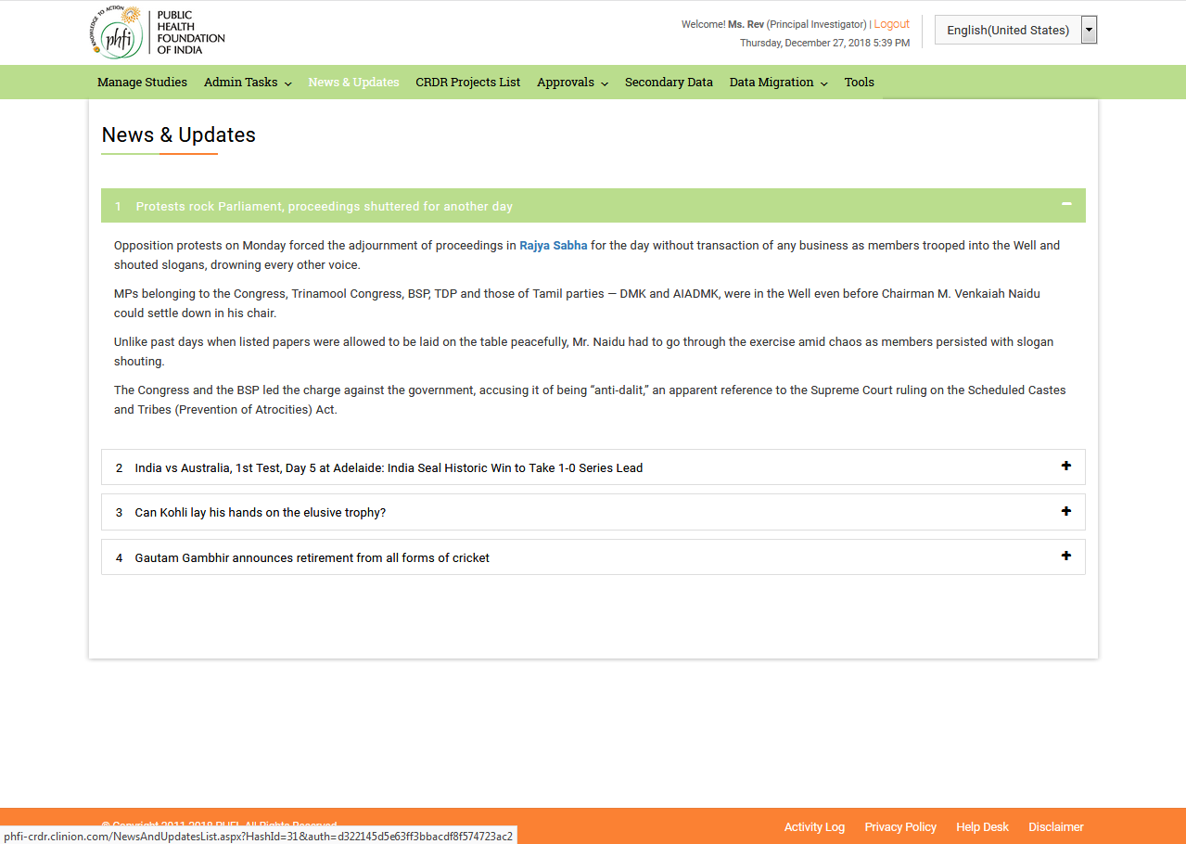

## 3.4 CRDR Projects List

CRDR projects list will be displayed in this module. The details related to the Ongoing, Closed and public projects can be viewed here. The access to the study can be requested and the guest user can understand the details such as PI details, Study type/ Status and category details.

Search Box:

The Search area contains a “Drop down” box and “Text Box” to enter the study details. An “Add icon” is available to make advance search.

* On clicking the drop down box, user will have the facility to select any of the following options “project Code”, “Category”, “PI Name”, “Project Status”, “Date Submitted”, “Move to Repository in Last Days”.
* There is a text box with “Enter Data” help text is available, to enter the study related data.
* On clicking “Add Icon” a new set of search boxes will appear along with another drop down with “And”, “OR” and “And/Or” options.

Study List Grid

* Study list grid contains ”Project Title”,s “Project Code”, “Category”, “PI Name”, “PIs Email Address”, “Status” and “Actions” details.
* There is a radio button to filter the “Ongoing”, “Closed”, “Public” is available. By default, “All” is selected and all the studies are listed out.
* Page Navigation at the bottom of the page allows to view details listed in different pages.

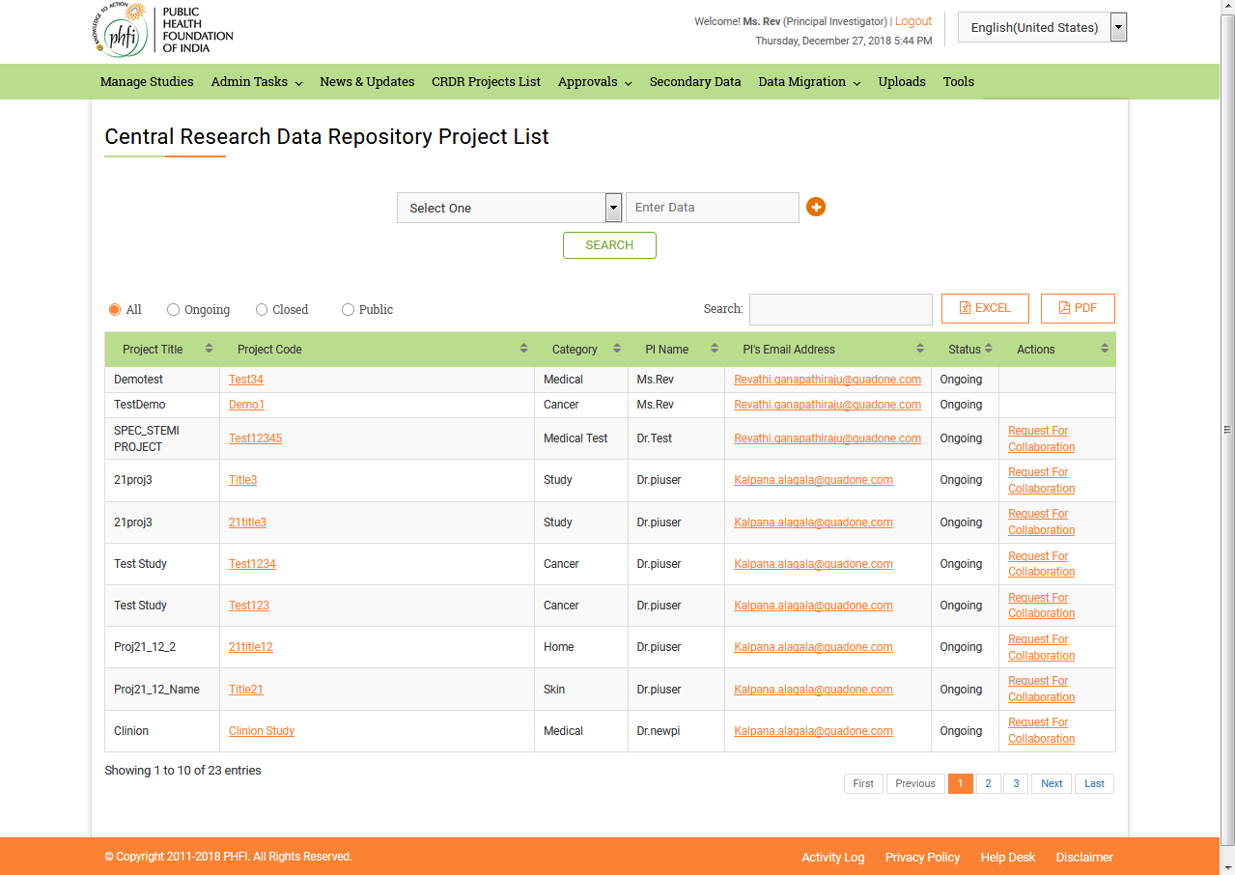 **Figure 05: CRDR Project List Page**

* The “Project Code” is given as a hyperlink in red. On clicking Study title link, user is navigated to a page where various open documents can be accessed. Study related documents are available in this page. The Related Documents are provided as separate sets at the left hand side of page. Various document sets include

1. Data sets catalogue
2. Reports Catalogue.
3. Other Documents
4. Public Documents

Of the sets access is provide only to public documents. Permissions for the documents can be requested using “Request for Collaboration” menu available on the top of page. [Note: This form is same as that available on CRDR Projects List page. In detail description is provided in further section of this manual]

* Other menus available at the top of the page include: “Back to CRDR Project List” to navigate to list page and “Back to Home page” to navigate directly to Home page.
* At the bottom of page Read me file details are available.

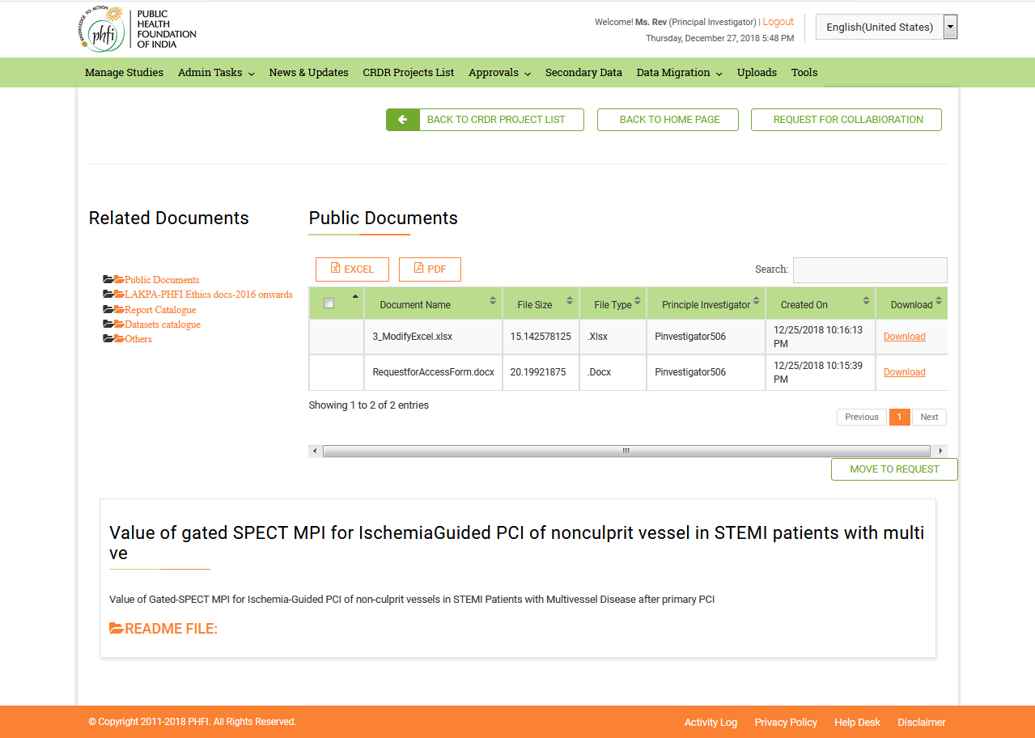

**Request For Collabaration**

For all the public studies, Guest user can “Request for Collabaration”. Once the Request for access is approved he/she will become the signed user and gets permissions with application.

* On clicking “Request for Collabaration”, a pop up request form will appear on the screen with details to be filled for

1. Your Name
2. Email ID
3. Mobile
4. Comments
5. Upload File

And Submit or Clear options. The Request Form can be downloaded using “Click here to Download” option. The downloaded Request Access Form has fields to be filled up and this can be uploaded using “Upload File” menu.

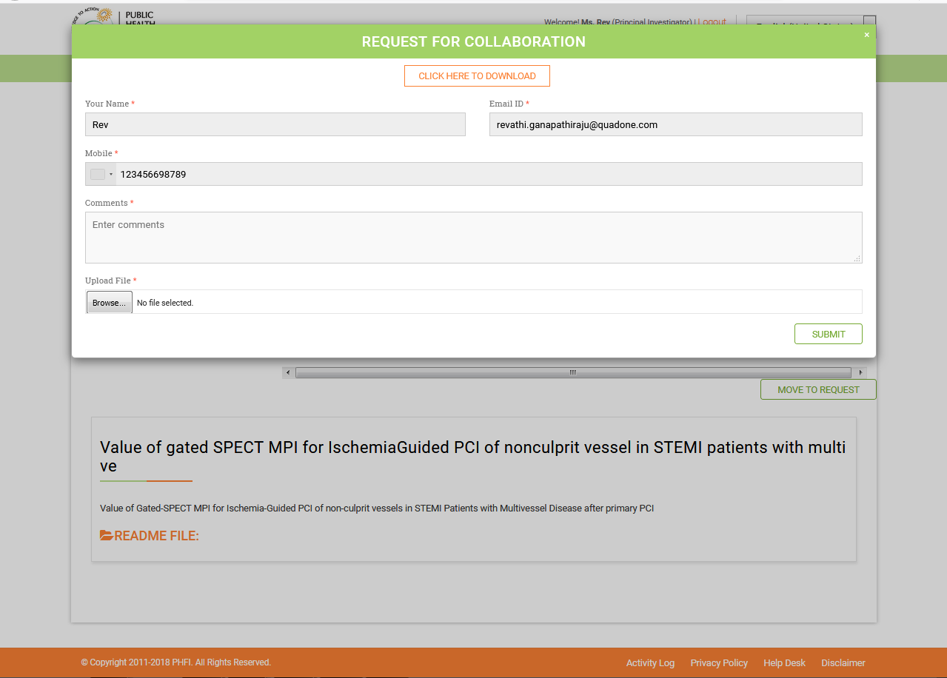

## 3.5 Approvals

#### Project Requests

Guest user have the facility request access for the public studies. The request for the access to a study or any document related to study will be sent to the respective for approval. All such requests for projects will be available in “Project Requests” menu.

PI can either Accept or Decline the request. The request once accepted can also be Revoked.

With help of Study tile hyperlink, PI can provide access for all the documents or for selected documents for a particular time period (between two dates).

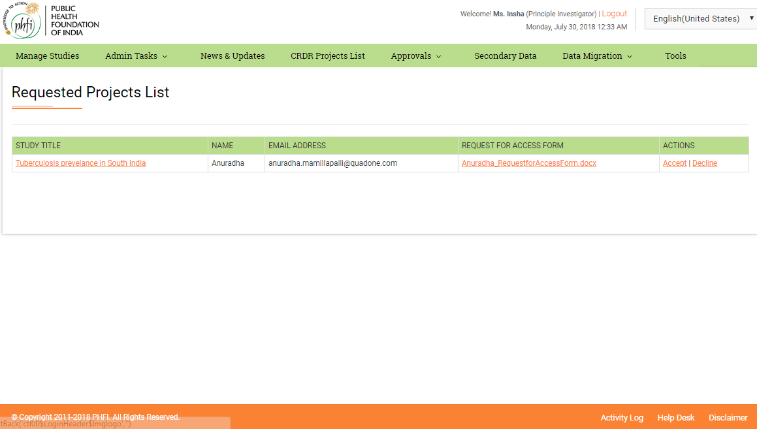

User have an option to choose between the requested documents and accept only the desired documents for a given time period.

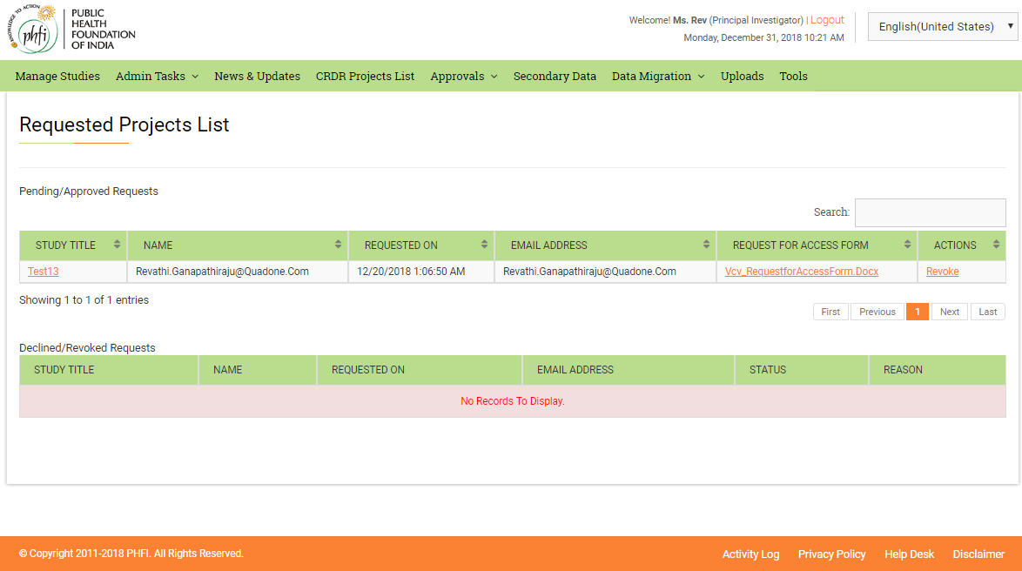

The accepted access can be revoked any time between by providing a reason for revoking.

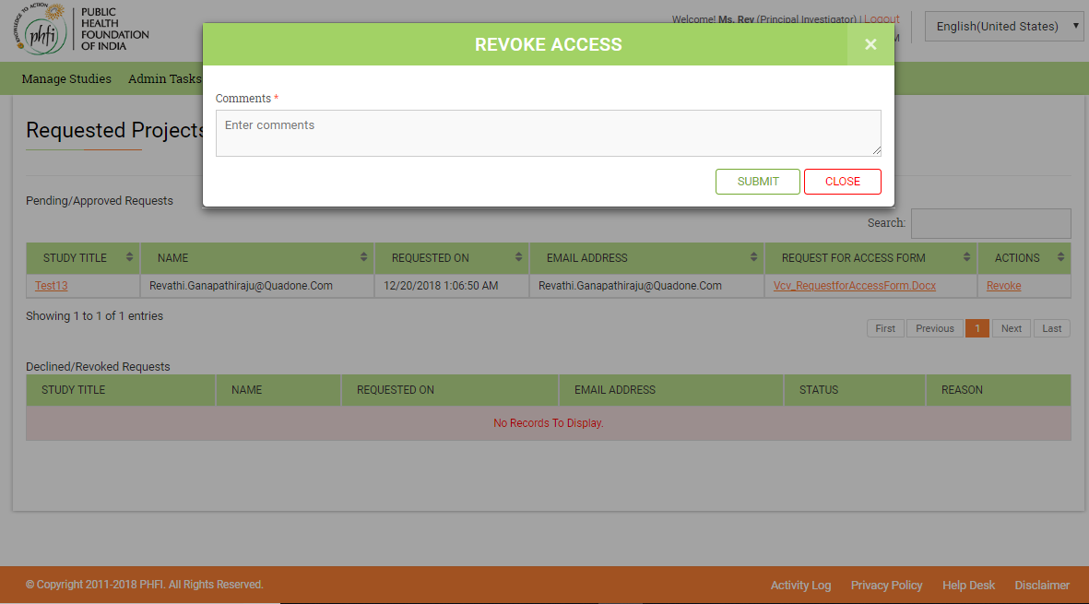

#### Secondary Data Requests

The requests to view the subscribed documents will be available in this menu. When an access for an subscription is required request can be raised from “Secondary Data” module. All those requests will reflect in Secondary data requests menu. Owner of the subscription can either accept or decline the subscription.

On Accepting the request, the user who raised the request shall have the access to the subscribed link or files.

#### Collaboration Requests

All the collaboration requests for the studies (respective to PI) shall be available in collaboration Requests menu.

PI user can accept or decline the request.

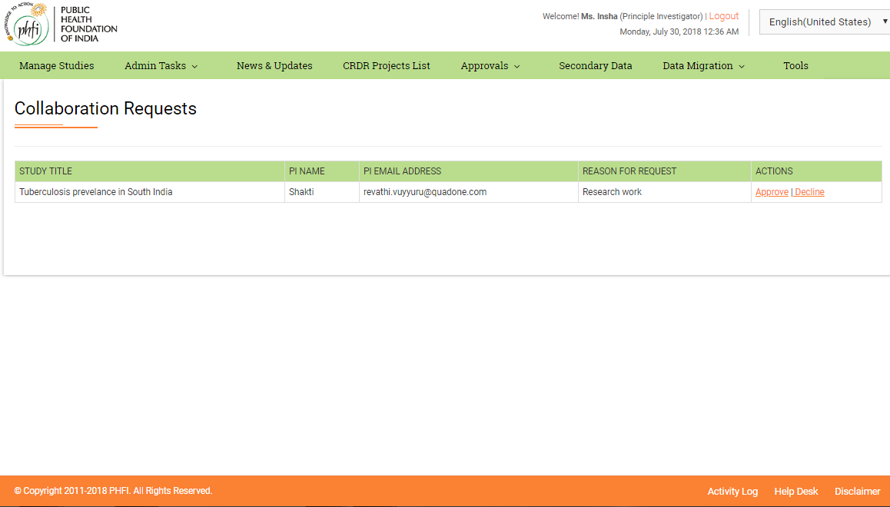

## 3.6 Secondary Data

Secondary data module helps in viewing the subscriptions added by Super admin and further attaching the datasets to the added subscriptions. Both scientific and Nonscientific data related subscriptions made can be viewed.

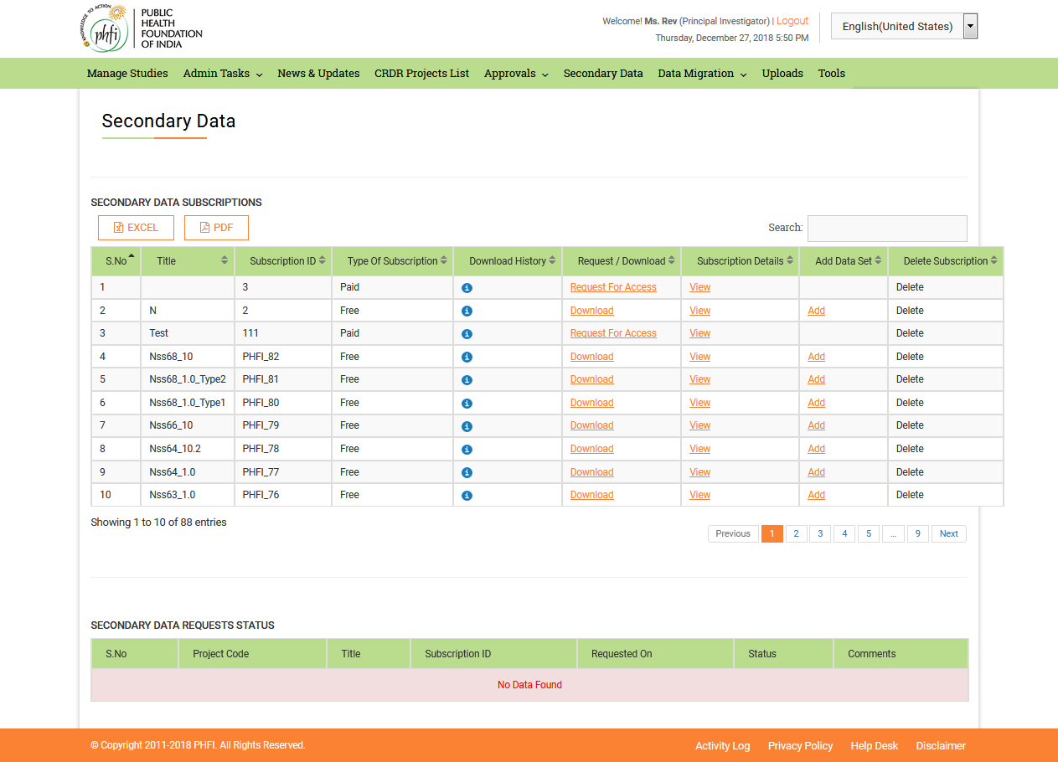

View Subscriptions Details: On clicking the “View” Subscription details will appear as pop up. All the details entered while adding the subscription will be displayed.

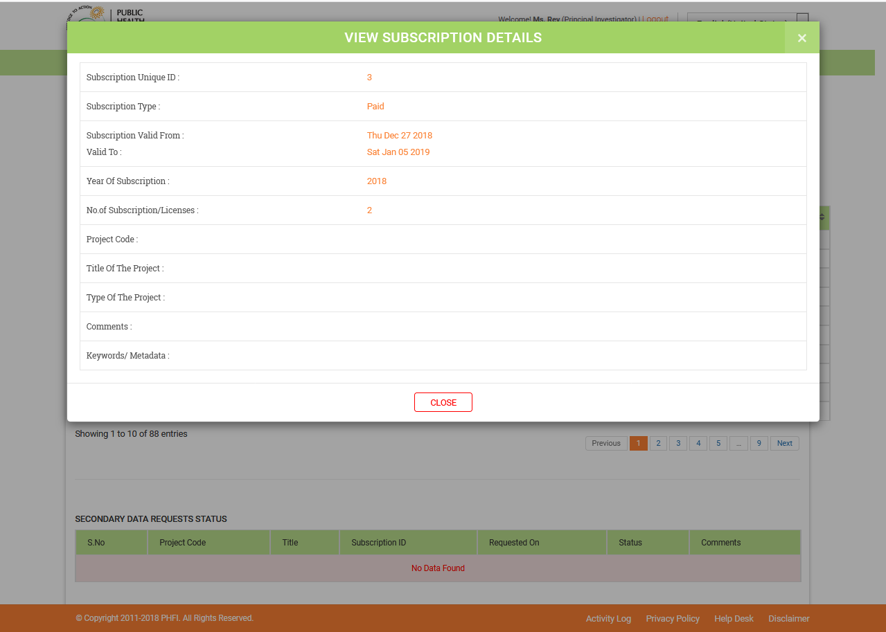

Adding Data Set

“Add” button in the last column of the table is used to add the further versions, or sub versions or related versions to the existing subscription.

* On clicking the “Add” link, a pop up menu to fill the details

1. Type: the details like “Link” or “File” can be selected here. If “Link” is selected is “choose file” option is disabled. And when “File” is selected, “Link” details will be disabled.
2. Link
3. Year of Subscription
4. File (Choose file)
5. Comments

* On clicking the Submit, the data set will be added successfully.

